

ADHD
Attention Deficit
Hyperactivity Disorder

Information Booklet for Parents/Carers

For further information please contact
ADHD CAMHS Team
02838360680

The purpose of this information booklet is to help you to begin to understand your child’s diagnosis. Greater understanding is the key to helping you and your child make sense of ADHD and manage its symptoms. Further reading is recommended and a list of resources can be found at the end of this booklet.

CONTENTS
- Introduction
- History and Definition of ADHD and where we are today
- The Prevalence of ADHD
- Characteristics of ADHD
- Inattention
- Impulsivity
- Hyperactivity
- How is it is Diagnosed?
- What causes ADHD?
- Other possible problems
- Management of ADHD
- The use of Medication And ADHD
- Famous people with ADHD
- Useful Information

- Introduction
Attention Deficit Hyperactivity Disorder (ADHD) is a medical condition recognised worldwide. It is most commonly diagnosed in children and can continue into adulthood. Boys are more than twice as likely to be diagnosed with ADHD as girls. Adults can demonstrate symptoms and be diagnosed as well.
Despite many years of research, a diagnosis of ADHD remains tricky given the many problems that define it.

- History of ADHD
The symptoms of the ADHD were firstly reported by Scottish-born physician and author Sir Alexander Crichton in 1798. He described a mental state presenting with restlessness, problems with attention, the early onset and how it can affect the ability to perform in school.
The term ADHD was first mentioned in 1902 by British Paediatrician Sir George Still. He found that some affected children could not control their behaviour the way a typical child would.
In 1937 Dr Charles Bradley stumbled across some unexpected side effects of a new drug. Young patients’ behaviour and performance in school improved when he gave it to them. These findings were largely ignored at the time. However many years later researchers began to recognise the benefit of what Bradley had discovered.

The disorder gained formal recognition in 1968 in the ‘’Diagnostic and Statistical manual Mental Health Disorders’’ (DSM). Doctors today diagnose ADHD using detailed criteria spelled out in the most current edition of the Diagnostic and Statistical Manual of Mental Disorders (DSM).
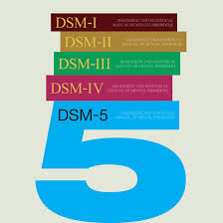

ADHD is a neurodevelopmental condition, defined as a:
“disorder of age-inappropriate impulsiveness, inattention and hyperactivity”
(DSM IV; APA 1994).
In 1987 the third version of the DSM established the three presentations of ADHD used by health care professionals today;
- Combined type ADHD
- Predominantly inattentive type ADHD
- Predominantly hyperactive-impulsive type ADHD

- Where we are today
Scientists are trying to further explore the causes of ADHD as well as the possible treatments. Research points to a very strong genetic link. Children who have parents or siblings with the disorder are more likely to have it.
It is not currently clear what role environmental factors play in determining who develops ADHD. Researchers are dedicated to finding the underlying cause of the disorder. They’re aiming to make treatments more effective and help find cures.

- The Prevelance of ADHD

The prevalence of ADHD varies in the literature for the primary school age population. It is estimated at 5 – 7.01% worldwide by Polanczyk G et al (2007) and Willcutt (2010).

In the UK the prevalence rates for 5-16 year olds have been found to be 2.6% for boys and 0.4% for girls (Green 2005).

It is reported that approximately 65% of children with a diagnosis of ADHD continue to display symptoms into adulthood, Faraone, S et al (2006).

- Characteristics of ADHD
The core characteristics of ADHD are excessive;
- Inattention
- Impulsivity
- Hyperactivity
It is cause for concern when the above symptoms are more excessive than other children of their age and cause difficulty in two or more environments, most commonly school and home. Any learning difficulties are taken into account.

Inattention in children with ADHD

In school when compared to children of a similar age children with ADHD have difficulty concentrating and remaining on task. Their inability to focus their attention leads to distractions and off task behaviours.

Often loses things necessary for tasks

Often has difficulty organising tasks and activities

Difficulty sustaining attention during activities

Avoidance of activities that require sustained mental effort

Is easily distracted by extraneous stimuli

Failure to give close attention to detail or making mistakes

Is often forgetful in daily activities

Often does not listen to when spoken to directly
Difficulty in following instructions and failing to complete tasks

Symptoms of Inattention
Impulsivity in children with ADHD



This causes children to act before they think as they are unable to control their initial response to the situation. The ability to ‘’self-regulate’’ is compromised; they can’t modify their behaviour with future consequences in mind.

Children can often be labeled unruly or aggressive because of their impulsive physical and social interactions. Even though these children can be caring and sensitive, their good qualities are often overshadowed by their poor impulsive control.
Many children with ADHD seem to spend much of their time grounded or in trouble for what they say and do. The lack of impulse control is perhaps the most difficult symptom of ADHD to modify. It takes years of patience and persistence to successfully turn this around.
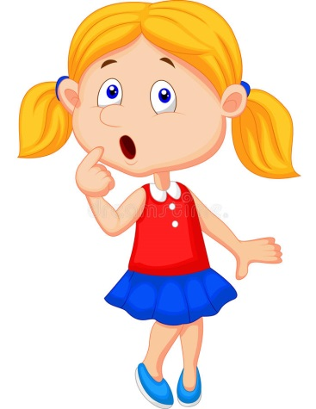
By the time I figure out what I’m gonna do…. I’ve already done it!

Symptoms of Impulsivity
Often blurts out answers before questions have been completed
Often has difficulty waiting turn

Makes important decisions without considering long term consequences

Often interrupts or intrudes on others

Reckless behaviour and accident prone

Hyperactivity in children with ADHD

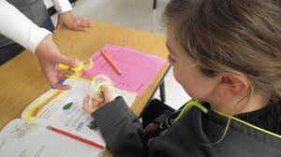

Children who are hyperactive are usually constantly active, excessively restless and easily aroused emotionally.
The speed and intensity by which they move physically and emotionally is greater than peers of a similar age.
Response to discipline from a teacher or parent is short lived and the child returns to the undesired behaviour or moves on to something else. This can be quite intolerable for parents and teachers. Children are often accused of lacking guilt/not sorry.

Often runs about or climbs excessively in situations in which it is not appropriate

Often talks excessively

Often dos not seem to listen when spoken to directly

Symptoms of Hyperactivity
Often fidgets with hands or squirms in the seat

Often leaves seat in situations in which remaining seated is expected

Is often ‘on the go’ or acts as if ‘driven’ by a motor

Often has difficulty playing or engaging in leisure activities quietly

How it is diagnosed?
The Community Pediatrician or a CAMHS Practitioner who has concerns about a child’s inattention, hyperactivity and impulsivity can refer to the CAMHS ADHD Team.
The Team will undertake some or all of the following interventions, not necessarily in this order-
· School Observation
· Behaviour History/ Assessment
· QB testing
The above assessment reports will then be discussed with the referring practitioner and a diagnostic decision or further interventions will be agreed upon.

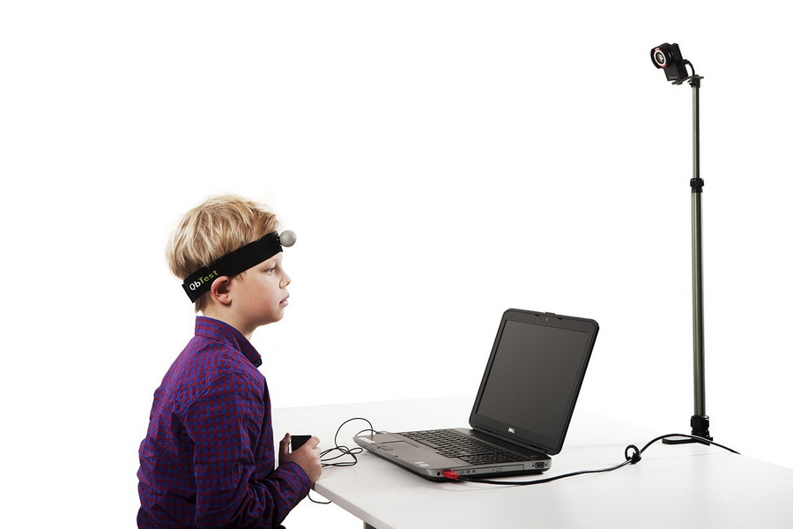

What causes ADHD?
ADHD has a number of likely causes – though the medical community cannot pinpoint which one exactly explains the symptoms. It’s not completely known what causes ADHD.
What we do know is that ADHD is not caused by bad parenting or too much sugar. It is a brain-based, biological disorder. Brain imaging studies and other research show many psychological differences in the brains of individuals with ADHD.

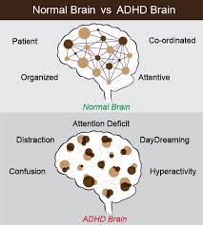

Fundamentally the area of the brain that keeps the rest of the brain well organised (front part) is under active. Evidence suggests that the disorder is caused by a complex deficiency or imbalance of certain chemicals in the brain. The neurotransmitters dopamine and noradrenaline are known to be involved. Research is ongoing.

Other studies reveal that a child with ADHD is 4 times as likely to have had a relative diagnosed with the condition – clearly pointing to a genetic factor. Other possible causes of ADHD include;
    - Exposure to drugs, nicotine or drinking alcohol during pregnancy
    - Low birth weight
    - Premature birth
    - Brain injury

Other possible problems – co-morbidities
About half of all children with ADHD have co-existing conditions, called ‘comorbidities.’
A comorbid condition is a separate condition that exists alongside ADHD for example learning disability, speech and language issues conduct disorder, tics, Tourette’s, anxiety/depression, Social Skills or motor skill problems. These difficulties further impact on a person’s skills and abilities.

- How is ADHD managed?
ADHD is a disorder that cannot be cured and therefore must be managed throughout the child’s life span. It is therefore vital that we become informed about the disorder, understand ADHD, its related problems and treatments and try seeing the world through the eyes of the child.

.

“Wanting to” manage your ADHD (or that of your child) is important, but experience and research tell us that even strong determination isn’t always enough.
It takes Education, Desire and Energy to manage ADHD:

Education
After diagnosis, most people do a lot of research about ADHD. This is good, but it’s important that the material is accurate. There is a lot of misinformation about ADHD. There are a number of books about ADHD. See list of recommended reading at back of booklet.

Structure & Routine
Lack of structure is a major problem for people who have ADHD. For most people with ADHD there seems to be no internal system of organization. This lack of internal structure must be compensated for by creating external systems of organization.
Children with ADHD respond best in a well-structured, predictable environment where expectations and rules are clear and consistent, and consequences are set down ahead of time and delivered immediately. The magic ingredient in all this is your energy and how you learn to use it to nurture the behaviours you want and rules you decide on.
Praise and Encouragement
Help build your child’s self-esteem and encourage good behaviour. Try to praise your child more than criticize. Notice and acknowledge little changes and small successes.
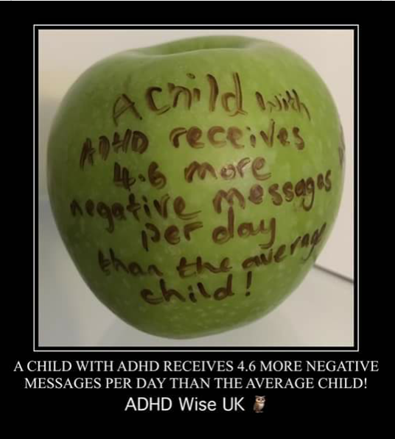

Facing the challenges

Do your best to do what needs to be done. You will not get it right every time. When this happens, step back, regroup, and try again. Do not be afraid to ask for help from family, friends or professionals.

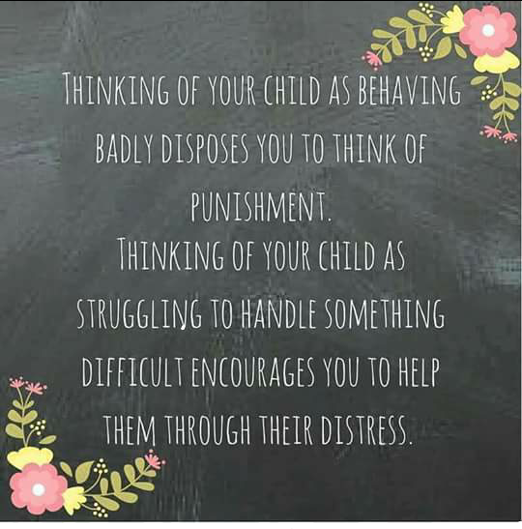

The Use of Medication in the Management of ADHD

For some children, it is appropriate to try the use of medication (whilst continuing behavioural measures). A multi-modal approach should include, where appropriate, psychological intervention, education, and medication. This then has the greatest chance of alleviating the multiple difficulties faced by many children living with ADHD and of enabling the child to “learn” strategies whilst supported by medication. This means a child is more likely to be successfully weaned off medication at a later date.

The medication most used is Methylphenidate - often known as Equasym, Concerta, Ritalin and Medikinet.

Methylphenidate can allow the child to improve attention and increase academic productivity but not necessarily achievement. It can reduce disruptive and impulsive behaviour. The child will often get on better with other children.

It does not stop difficult behaviours but makes it easier for the child to “learn” more appropriate behaviour with time.

Medication is carefully monitored. It is only continued if there are positive results with insignificant side effects.

Children are usually started on a low dose which is then
increased if necessary until it is helping to control symptoms.

Despite its general effectiveness, medication can have unwanted side effects. The most commonly seen side effects include appetite suppression (this can be helped by ensuring medication is given with or after food), tummy aches, headaches, loss of sparkle/sadness, sleep difficulties and irritability.

Medication can trigger the appearance of Tic behaviours.
Effective communication between the child and family, school and the medical team involved is essential.

It is important that medication for ADHD is stored safely and securely within the home.

If you have any concerns regarding your child’s medication please contact your GP, Community Paediatrics’ or CAMHS.

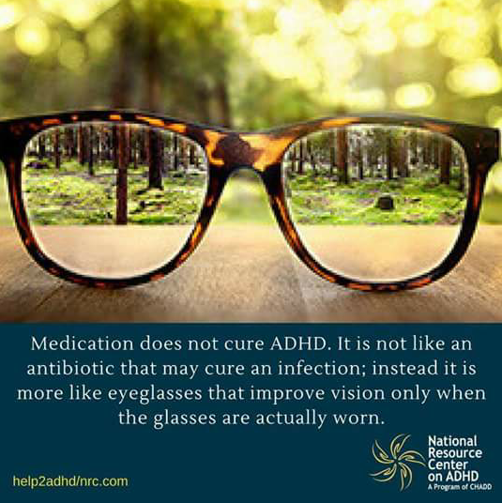

References USEFUL INFORMATION

Attention Deficit Hyperactivity Disorder: Diagnosis and management. Nice Guideline (NG87)
Updated 13/9/2019

WEBSITES

http://www.addiss.co.uk ADD Information Services and Support is a registered charity run
by Andrea Bilbow. Main stockists of ADHD books and related material in the UK. Andrea is
also the organiser of many of the major conferences in the UK.

http://www.additudemag.com
ADDitude Magazine is the quarterly consumer publication about attention deficit hyperactivity disorder. It covers treatment, parenting & discipline, school & learning, productivity & organization, emotional health, and much more. ...
www.ddni.net
http://www.moodjuice.scot.nhs.uk/anger.asp
https://www.rcpsych.ac.uk/
https://youngminds.org.uk/resources/tools-and-toolkits/amplified-resources/#amplified-resources

BOOKS
Understanding ADHD. By Christopher Green
An excellent guide to understanding ADHD in children.
ADHD Recognition, Reality and Resolution by Geoff Kewley
An informative guide to ADHD, for parents and teachers, with practical advice and case studies.

1-2-3 Magic by Thomas Phenlan
Effective discipline for children aged 2-12

ADHD A Practical Guide for Teachers by P Cooper, K Ideus.
This book is aimed at all teachers of pupils in the 5-16 age range.
I Would if I Could. A Teenagers Guide to ADHD by M. Gordan.
Written especially for the adolescent with ADHD, written with humour and a straight forward style.

Jumping Johnny Get Back to Work By M. Gordan.
A child’s guide to ADHD an amusing book for children aged 6-10.

The Hyperactive Child, A Parent’s Guide, By E, Taylor.
Taking Charge of ADHD, By Russell Barkley

The ADHD Handbook – for Parents and Professionals, By A, Munden.
An easy to read guide to ADHD written by two UK practicing Child and Adolescent
Psychiatrists.

How to Talk so Kids Will Listen so Kids Will Talk, By A, Faber and E, Mazlish.
An excellent book on how to parent all children, effectively without confrontation and punishment. Learn how to help your child attain a positive self image. This book has been used effectively here and in the US as part of a programme of parenting classes and
workshops for children with ADD.

Hyperactivity Why won’t my Child Pay Attention? By Drs S, M, Goldstein.

