For the purposes of Daily Mortality Surveillance the Public Health Agency has requested that individual patient level data is supplied from the reporting clinician as per the following PHE case definition

- Any inpatient who died within 28 days of their first positive SARS-CoV-2 specimen result, whether or not COVID-19 was the cause of death

The appropriate clinician, following completion of the standard process for recording deaths on the NIECR electronic system for those inpatients that had a first positive SARS-CoV-2 specimen result within 28 days of death the PHA COVID-19 Patient Deaths - Reporting Form must be completed and submitted electronically.

The Webform has identified mandatory fields with and asterisk*, but are requesting completion of as many of the other fields as possible to inform public health actions.
Please refer to the screenshot overleaf

This electronic submission to the PHA will replace the requirement to telephone to notify regarding COVID-19 related inpatient deaths.

It is important to note that completion of this form is dependent on the presence of a first positive SARS-CoV-2 specimen result within 28 days of death whether or not the cause of death COVID-19 is recorded on any part of the Medical Certificate of Cause of Death.

If you have any queries please contact PHA via flusurveillance@hscni.net

OR

The M&M Team at SHSCT via E.andE@southerntrust.hscni.net

Step 1. Access and Complete the PHA COVID-19 Patient Deaths - Reporting Form
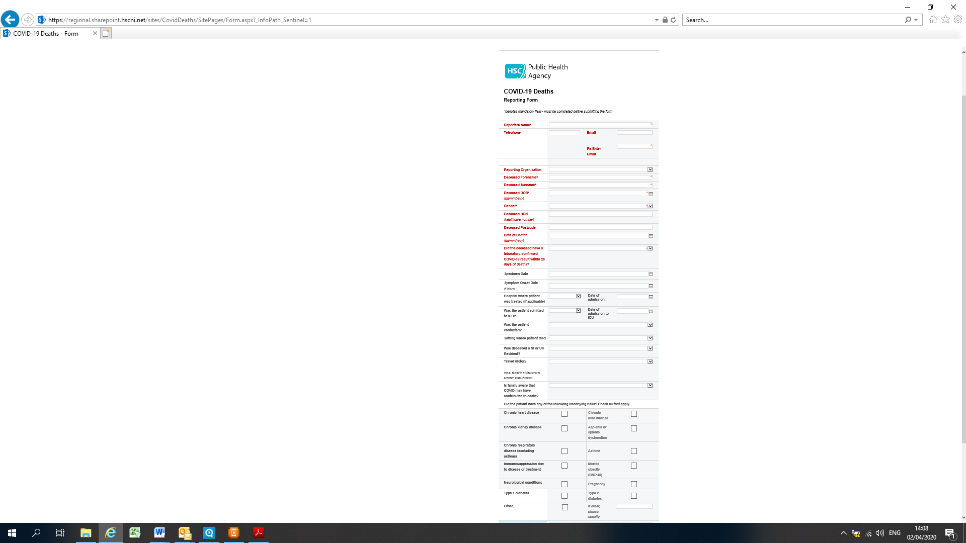

Step 2 - Submit

