Please Click Here for all: COVID-19 - Guidance surrounding death | Department of Health

1. Using NIECR, All Medical Certificates of Cause of Death (MCCDs) and Stillbirth Certificates should be sent via email to:
TO: GRO-pandemic@finance-ni.gov.uk
CC: M&M.Feedback@southerntrust.hscni.net
Providing the name and contact details for the next of kin in the email. Providing these details is vital to allow the GRO to contact the informant to obtain information required to register the death.

If known, the name of the Funeral Director being instructed by the family should also be included. If the Funeral Director information is not known, there is no requirement on the Certifying Doctor to obtain it as the Registrar can source from the informant when finalising registration.

With the removal of the requirement for the certifying doctor to have treated the deceased within 28 days, this will also impact on referrals to the Coroner. This allows deaths that would ordinarily have been referred to the Coroner for certification using the Form 14 (Pro-forma) process to be certified using a MCCD. If the death is not thought to be of natural causes and is in any way suspicious or unexpected the death should still be reported to the Coroner as per Section 7, for their appropriate action.

2. To send the MCCD via email directly from NIECR
Please click into the MCCD link under ‘Notifications & Legal Documents’ as you would normally to print.
Please refer to the screenshots overleaf
(1) Click on the Adobe symbol to show the full toolbar
(2) Click on send file as email icon. (Sending link does not work)
(3) Click ‘send copy’ option. Send using the default email application and not webmail.
(4) Check the ‘remember my choice’ option (only needs to be done once)

Please change the email subject line to - Trust Name and the Patient Health & Care number e.g. SHSCT - 330488XXXX and

The Email is now ready to be sent with the MCCD .PDF attached called ‘process.action’. Currently this cannot be renamed automatically.

Please do one final check to ensure the H&C number in the subject line of the email matches the H&C contained in the .pdf attachment being sent. Example test patient email attached.

In the event of NIECR system failure please refer to the Business Continuity Plan and revert back to using the old MCCD books to certify, scanning and emailing the MCCD to the same address again GRO-pandemic@finance-ni.gov.uk including the next of kin and if known, funeral director details.

Location of Paper Death Certificate Book – 28.3.2020

Directorate | Site | Location
Acute | CAH Main Hospital | Patient Flow – Bleep 1369 to request death certificate book
Acute | Daisy Hill Hospital | Patient Flow – Bleep 2446 to request death certificate book
Acute | Acute Care at Home | AC@H Office - Lurgan Office
CYP | CAH Blossom Ward | Black Box, Sister’s Office
 | CAH Neo-Natal | Store Room Cabinet
 | DHH Paediatric Ward | Patient Flow – Bleep 2446 to request death certificate book
MHLD | CAH Bluestone Unit | Contact Patient Flow CAH
MHLD | Gillis Ward, St Luke’s Hospital | Ward Safe
OPPC | Lurgan Hospital | Ward 1 – Paper Death Certificate Book kept beside the Mortuary Book (Nurses Station front wing)  Ward 2 – Paper Death Certificate Book in black box in Sister’s Office  Ward 3 – To borrow from Ward 1 or Ward 2
OPPC | South Tyrone Hospital | Dr P Stinson’s Office – Clip on drawer but not locked

1.
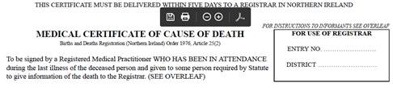

2.
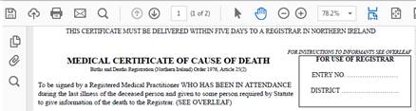

3.
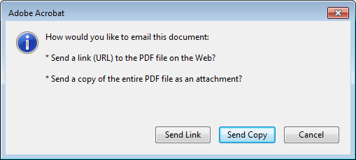

4.
