 | Appendix 4  Non-Acute Site Transfer procedure

 |  | 
- Inform Funeral Director in advance of suspected or known COVID-19 positive. If necessary, inform Mortuary CAH, 02837560220. | - Two Registered nurses MUST CONFIRM & CROSS CHECK Patient Identification & double sign the documentation. DO NOT REMOVE wrist bands. | - 3 POINTS of identification are required at minimum (name, DOB, HCN, etc)
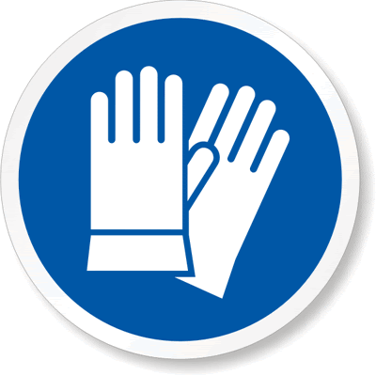 | 
- WEAR appropriate PPE. COVER the remains head / mouth before moving. | - SHROUD the body as per normal. Apply an appropriate amount of TAPE to hold the shroud in place. | - Place the remains into a BODY BAG and seal.
 | 
- Place at least TWO forms of ID on the Body bag, one in the ID pouch and at least one ID sticker on the body bag - 3 points of ID are required at minimum (name, DOB, HCN, etc)   | - Decontamination:  The outer surface of the BODY BAG with 1000ppm (0.1%) available chlorine. i.e. Actichlor Plus | - Decontamination:  The trolley or bed / and wheels with 1000ppm (0.1%) available chlorine. i.e. Actichlor Plus
- The Funeral Director arrives to collect the deceased. The Funeral Director does not enter the ward. Handover is completed in the designated area for release. | - Body Transfer Form must be completed and retained in patient notes. MCCD must be completed on NIECR or release proforma from consultant in place before handover and release. | - All staff involved in transfer to wear appropriate PPE: Gloves and apron

