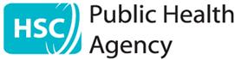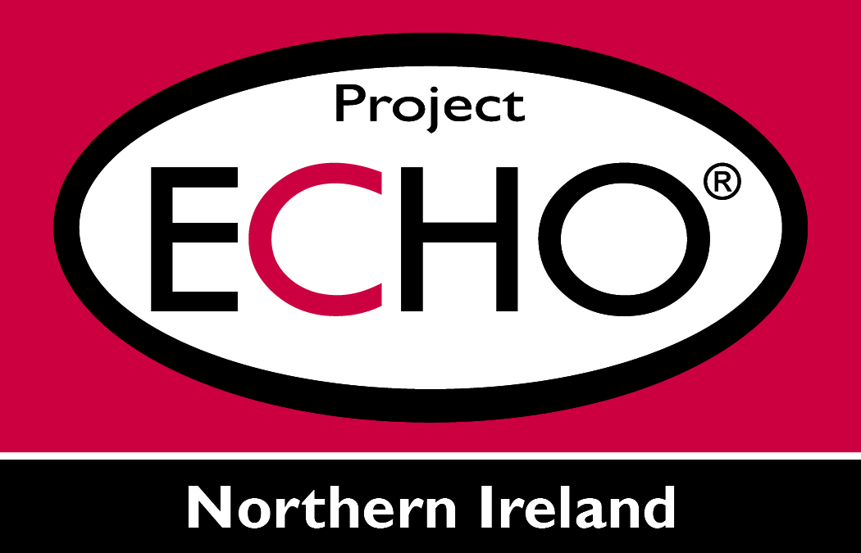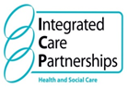

COVID-19 ECHO for Care Homes
Environmental Cleanliness for Housekeeping & Domestic Teams

Facilitated by The Public Health Agency in partnership with Belfast Trust

3rd June 2020 13.00-14.30

If you have not registered for the Public Health Agency ECHO Network please follow the link for Registration:-

https://tinyurl.com/yx5bwlea
1. From PC/Tablet - To download zoom software
Please click on the link below to download zoom software and join the meeting. Please ensure you join by computer audio.

https://echo.zoom.us/j/2174103961

If you have Zoom software
If you already have Zoom on your system, click join a meeting. The meeting ID is 2174103961

