
Event Summary
Care Home Activity Co-ordinators
ECHO (Care Home Network ECHO)
27 November 2020: 11:00 - 12:30pm

The NI Care Home ECHO Network held a session for Care Home Activity Coordinators on 27th November 2020

The session focussed on sharing activity ideas for resident’s whose opportunity for activities have been limited due to the Covid-19 pandemic.
Presentations included:
- Care Home Resident
- Care Home Activity Coordinator
- PHA Lead Infection Prevention Control Nurse
- Linking Generations NI –specialising in the promotion of intergenerational practice. Creating opportunities in all sorts of places and for all sorts of reasons for different generations to learn from, support, meet and enjoy each other
- Mid-East Antrim Agewell Partnership – a local inter-agency based partnership aimed at improving the lives of older people - presentation on an intergenerational initiative between 7 Care Homes and 7 primary Schools – and how they have carried out activities during Covid-19
- Church/Faith Group Representative – a presentation from a Faith group on how they are continuing links with Care Homes over the Christmas period.
There were 159 links established to attendees during the session from the independent and statutory sector and included RQIA, HSCB, PHA HSC Trusts – AHP and Care Home staff. There was interaction during the session with details of questions raised in the “chat” room and a short session in one of the 13 breakout rooms.
A further event has been planned for the 22nd January 2020 – further details to follow.




Should you wish a facilitated zoom session before this, specifically for discussion and sharing of ideas pre-Christmas please contact joy.peters@hscni.net before 10th December 2020 and we will try and accommodate this.

Care Home Activity Co-ordinators ECHO Session
- Care Home Resident, Betty Pickering, Sunnymead, Armagh:
Betty Pickering is a resident in Sunnymead Care Home and she read two poems she had written during COVID during one of the Poetry writing sessions set up by the activity coordinator. This really set the scene and captured the heart of the session.
For inspiration

It’s not the things that can be bought
That are life’s richest treasure
It’s all our friends in Sunnymead that
Are worth more
Beyond all measure
Let us trust for brighter days in 2021
And thank God for His mercy and
The gift of His dear Son

Christmas

Christmas is here
O my what a year
With hand gel and mask
Keeping each other safe
Is all we ask
We’ve danced and we’ve sang
We’ve read and we’ve prayed
Trusting and believing
Better days lie ahead
To all those we love
Take this special Christmas hug
Hold it close to your heart
Then we’ll not be apart
Happy Christmas one and all
And a healthy New Year
Giving thanks for Gods blessings
We send you good cheer


- Care Home Activity Coordinator, Kathryn Mitchell, Sunnymead:
Kathryn works as an Activity Coordinator in Sunnymead Care Home, Armagh.
Kathryn shared some of the ideas they have in place in Sunnymead over the next few weeks.

- Socially Distant Afternoon tea sessions in the conservatory for small groups of residents – to allow opportunity for residents to meet with each other and catch up in a safe manner – some extra wee treats on the plate.
- links with local groups
- Resident book gifts to families – Kathryn to share regionally
- School to send cards and letters to the residents
- Christmas scrubs to be worn
- Project with C21 theatre group to capture stories, will sit around the fire with hot chocolate to watch the short films and reminisce about Christmas

- PHA Lead Infection Prevention Control Nurse, Caroline McGeary

Caroline gave a presentation of some of the impacts of Covid -19 on the festive season and some ideas about what approaches can be used and adapted to ensure some Christmas cheer.
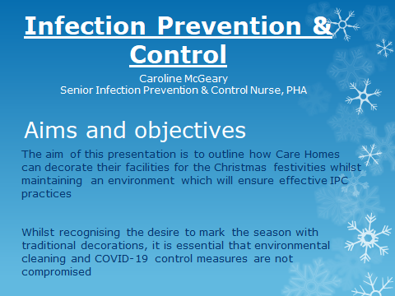

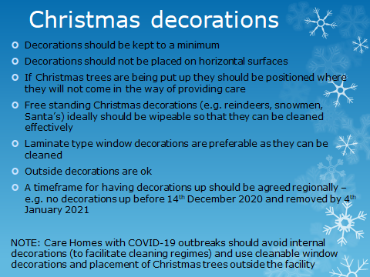

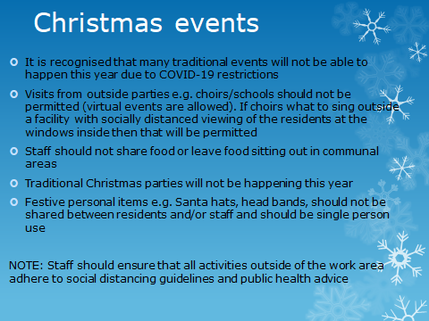

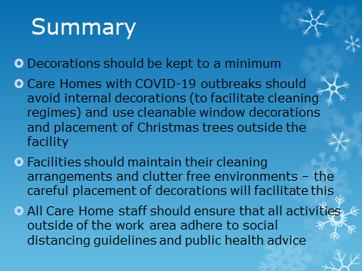


Bringing Music Activities to people living in care home settings

Bringing Music Activities to people living in care home settings; Covid 19 and beyond is on PHA website. The information and resources were coproduced and developed by a music therapist and AHP and Partners Support group. This information will provide activities and suggestions to support sensory stimulation activities and signpost to available online resources:
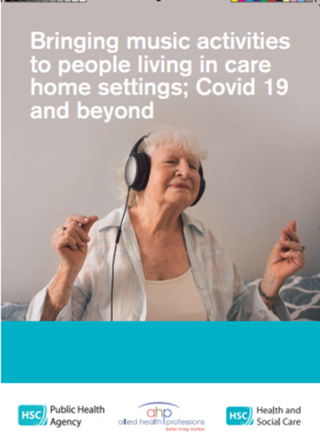
This publication is also available to download on the PHA website on the link below.

https://www.publichealth.hscni.net/sites/default/files/2020-11/20-10%20PHA%20Music%20Sensory%20Brochure%20AW%20Revised%20Print.pdf

Some additional information regarding singing
During the event there was discussion regarding safeguards which may be required for singing. Below is some information which explains quite clearly the range of measures that are advised to mitigate and reduce the transmission risk, in addition to ‘regular’ social distancing:
- singing at lower volume and not projecting voices (including using a microphone to amplify instead of singing loudly)
- social distancing increased to 3 metres not the usual 2 metres for anyone leading singing (and therefore singing more loudly)
- using as large a space as possible with good ventilation
- keeping singing sessions short and ventilating room immediately before and after
- all singers wearing masks to help prevent spreading aerosols and droplets
- positioning participants back-to-back or side-to-side where possible (not face-to-face with others singing) – the leaflet attached includes suggested layouts
and links on singing which you may find useful.
Gov.uk COVID-19: suggested principles of safer singing - (updated 20th November)
Gov.uk Working safely during Covid-19: Performing Arts- (updated 26th November)
It’s also worth remembering that any groups attending will have to adhere to current regulations (i.e. at present maximum of 15 people for an outdoor gathering, and still adhering to social distancing etc. School choirs may be slightly different re bubbling).
Attached is the “Keeping Singing Going” Leaflet for information and links

- Linking Generations NI – Lynne Bennett
Linking Generations NI specialise in the promotion of intergenerational practice. They create opportunities in all sorts of places and for all sorts of reasons for different generations to learn from, support, meet and enjoy each other. Lynne gave an overview of some of the projects they are currently involved in with others across the province.
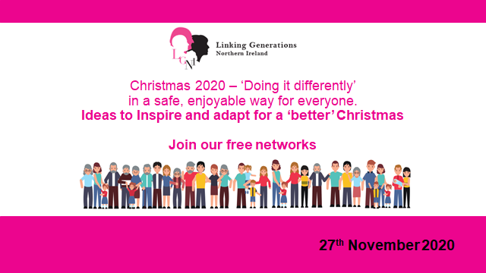

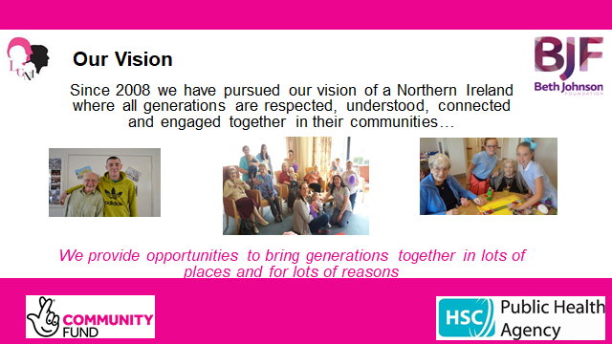

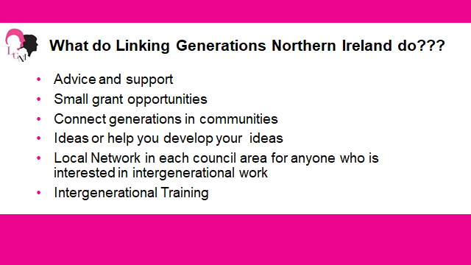

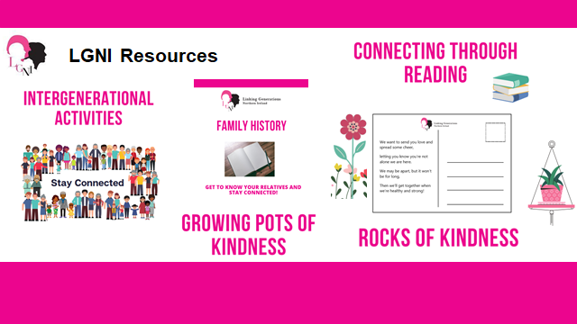

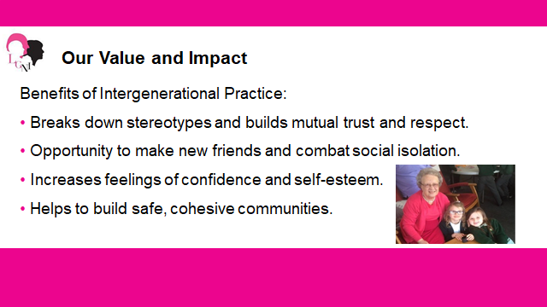

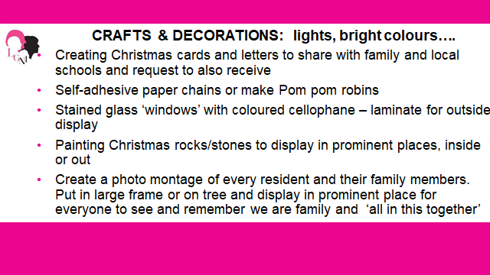

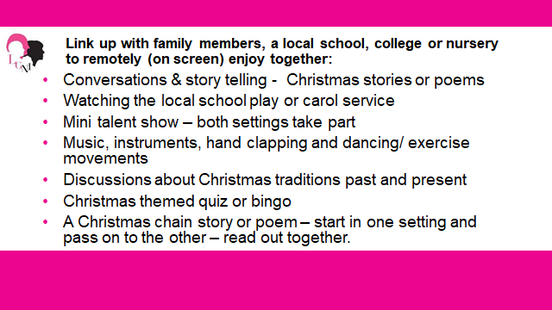

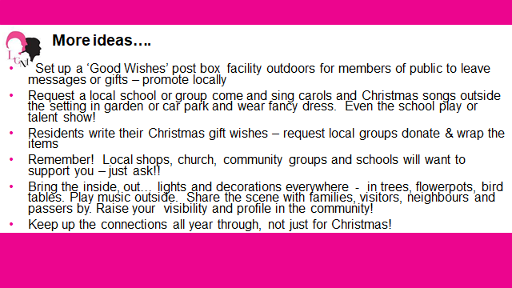

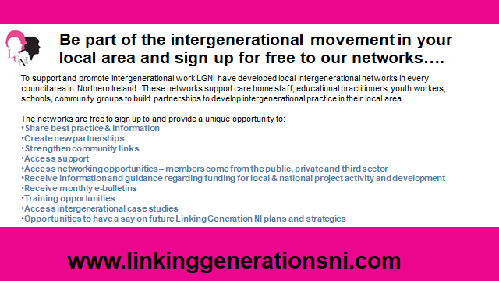



Lynne invited attendees to contact their local Linking Generations office to access the range of initiatives and contacts they have.

- Mid-East Antrim Agewell Partnership – Jenny Dougan
Principal Dunclug Primary School A Beacom

Jenny shared the presentation below and talked about the links MEAAP had with groups in their local area, including schools.

Alastair Beacom, Principal Dunclug Primary School, talked about the initiatives with Care Homes that the school are involved in, and highlighted the benefits to the school children of the intergenerational interaction.
Alastair spoke about the power of words and how the children had written poetry based on their interactions with the residents. It is also an opportunity to raise the profile of the home in the local community and to build ongoing relationships. It is hoped that Santa will zoom into a session with the children and the residents!
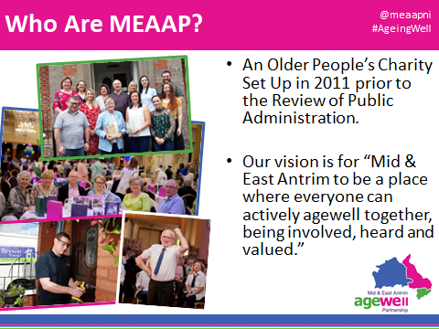


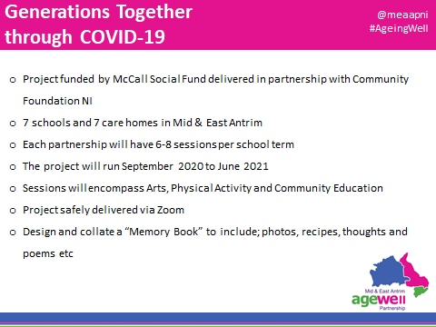

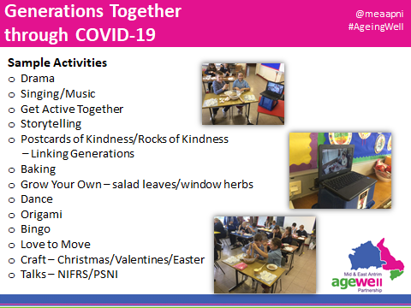

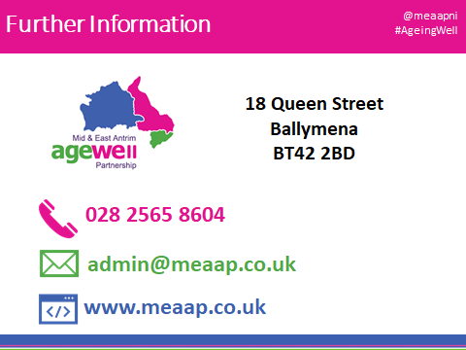

- Church/Faith Group Representative – Daphne Mahon – Fermanagh Christian Fellowship

Daphne spoke about the involvement she has through her local church with Care Homes in the Enniskillen area pre Covid – visiting, social events and sharing a message of Hope. Her church, Fermanagh Christian Fellowship, has pre-recorded a Christmas Carol Service. The links to the Carol service can be accessed via the website https://www.fcf.church and will be posted closer to Christmas. They have also arranged to do Carol Singing outside at some of the Care homes.
Daphne also talked about a group of people from different churches within the Fermanagh area who have been running a wee group called the Sparrows with residents in Care Homes for learning Disability. Sparrows has been running now for 31 years and a zoom Christmas party is being planned with the residents across the 3 sites. The organisers will leave a box of activities round with the homes in advance of the party and staff will support with the activities within the current guidelines.

Break Out Rooms
There were 12 facilitated break-out rooms and the discussions have been captured below in response to the 4 questions.
Q1 –What plans are in already in place for your Care home this Christmas?
- Joint choir of staff and residents. Will perform in all dining rooms throughout the home. Will dress up and have percussion to make it more cheerful.
- Christmas Movie and Takeaway night.
- Painting rocks and leaving them on promenade – rocks have messages as to what home they are from and hoping to hear back from members of the public (I’m sorry sound was bad for these ladies and didn’t catch where they were from).
- Resident designed cards – which will be printed so they can send to family and friends.
- Baking and decorating biscuits.
- Carol – okie.
- Singing together.
- Christmas tea party where distancing and bubbling allow for it.
- Some Homes are making Christmas baubles (which were mentioned at the feedback session and we were shown an example of a bauble with a hand on it to represent a hug) – they plan to take photos of these when they are finished.
- St Joseph’s in Warrenpoint are making baubles and Christmas decorations with their residents.
- Drapersfield Care Home have linked with the local school and school children will be sending letters into the residents in the Care Home and then the resident’s will be sending back Christmas cards that they are making.
- A Care Home in Enniskillen are also exchanging cards with a local school.
- Updating the notice board with ChristMAS activities to inform resident and family members/carers of What is On.
- Decorating residents windows/reception for Christmas
- Filling and decorating window boxes
- Arranged carol singers to come and sing for residents (social distancing outside)
- Christmas jumper wearing
- Christmas Bingo and other games arranged
Challenges:
- Independent Living Accommodation – difficult to get some residents to become involved in XMAS preparations/involvement.
- Loughgall – Apple House. Centre for residents with learning disabilities ranging from 28 year olds to 80 years old.

Q2 – What resources and links have you already made within your local community?
- We have established links with the Primary School next door and continue to exchange letters and now Christmas cards and little gifts.
- The Salvation Army come to play outside and hopefully will do so this year too
- We have links to a local school. This year they plan to record the Christmas nativity to share with us. Teachers are being very inventive!
- We get letters and boxes of chocolates from a local school.

Q3 – Have you heard anything this morning which has prompted you to think about doing some additional activities for Christmas, or into the New Year?
- Involving primary schools – the work presented by MEAAP and the principal was considered to be very worthwhile, some were not aware of this possibility.
- Changing the uniform to Christmas themed scrubs to signify the Christmas season.
- Window decorations.
- Asking the community, families and schools to share stories about Christmas particularly in the local area.
- Create zoom events for engaging families such as bingo etc.
- Have a good wishes post box. In one particular home a new resident was having to self isolate and the post box is seen as way of residents conveying a welcome message to that resident.
- Use Youtube to access local Christmas Carol services and where possible have singing outside.
- Put lights and decorations in the garden to ensure the home is recognised by the local community.
- Support residents to make videos for family members and ask families to do likewise.
- The Festive Season Book is a great idea which others want to adopt.
- Residents to exchange Christmas cards within their local Care Home network which may develop into “pen pal” relationships and reminisce about local areas and lead to further opportunities to meet up – face or face or virtually at a later date.

Q4 – What other links and resources, other than those presented today, do you feel would be good to establish?
- One of the Care Homes (Ardmaine) mentioned that they previously had links with the local museum where they would have brought in items from the museum to show to the residents and have a discussion about times gone by – I encouraged them to re-establish these links at a point in time after COVID where it would be safe to do this.
- Some of the Homes stated that they were new to the role and they were establishing links with their local schools and churches.
- Some Homes thought that establishing links with other Care Homes in their area would be good.
- Plan to establish a Good Wishes Postbox so that residents can communicate with each other.
- Develop more links with residents’ families – include them more.
- Develop links with local supermarkets and shops - The local Tesco and Dunelm have a ‘Giving Tree’ where people donate gifts and food items for the residents.
- Develop links with local Further Education colleges to provide students with opportunity to use their skills with residents i.e. ‘Pamper Days’.
- Keen to have another session like today in New Year with more ideas.
- Pen Pals between local care homes

Questions for poll at end of session
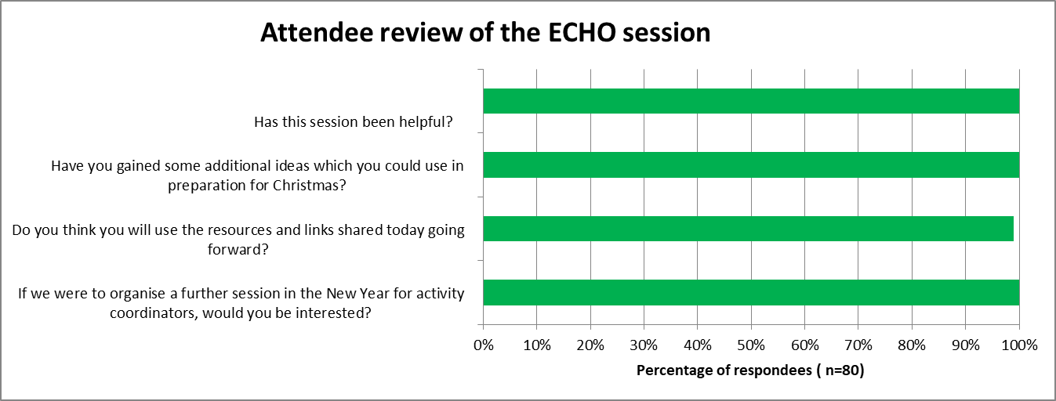

Summary and Next steps:
Thank you to all who attended and contributed to the Care Home Activity Coordinators ECHO session on 27th November 2020. It was very encouraging to note the feedback about the usefulness of the session and the interest in further sessions.
A follow up Care Home Activity Coordinators session has been arranged for Friday 22nd January 2021 from 2:00 to 4:00pm. Pre-registration for this event will be required to assist us link and create local networks. Further details will be forwarded closer to the time.

If Activity Coordinators would like further support and links before this date we would encourage contacting some of the organisations who presented on the 27th November 2020 and have included their contact details above.

Chat box summary:
Questions and comments
Q From DeputyManagerEdgewat : Hi There. Can I ask if we are allowed to put up Christmas decorations this year due to infection control with Covid?
A – Covered in the PHA Infection Control slide presentation.
Wonderful poem!
Beautiful poetry well done
Beautiful betty! Thank you for sharing!
Wonderful betty thank you so much for sharing
Beautiful, thank you betty xxx
Beautiful betty thank you
Absolutely beautiful betty!
Absolutely beautiful poems betty well done
That was lovely, just what was needed this morning. Thank you
Fantastic work betty
Thanku betty. Beautiful poems :)
From kathy fodey : great poem Betty, we will share your words with everyone on the call
From fiona.mccourt : PHA Website is worth checking for resources AHPS have developed information on Activity iideas and Music Therapy. Also The Royal College of Occupational Therapists have a Living Well in Care Homes Toolkit which is a resource available to Care Home staff via their website. Fiona Mc Court OT Care Home Support Team SHSCT
From Paula Tabakin : We have started to do a series on the history of Christmas traditions and the origins of some Christmas Carols
What an amazing lady with great poems. Catherine what great ideas
From HomeManager : Is it ok to use projectors in the Home?
Yes, as long as they are kept clean and decontaminated as per manufactures instructions
From Cushleyw : what about painting on the windows?
Preferable to have paintings outside but yes, painting on windows would be easier to keep clean than free standing decorations
From Life 9 : can decor be sprayed down with a strong disinfectant?
Decontamination products that are made up (which may contain sodium hypochlorite/bleach) should not be put in a spray bottle – this is in line with COSHH regulations
From Joanne McDonald : we have our residents in 2 bubbles. can these residents sing xmas carols, etc with or without ppe. if ppe what level
See information above re: singing
From DixonJe : can Christmas cards be displayed in bedrooms?
Yes, bedrooms should be kept as clutter free as possible to ensure effective cleaning
From Dungannon Care home : what about Christmas jumper day for residents and staff is this allowed.
Christmas jumper day is ok – as long as the appropriate PPE is worn when providing direct care
From shannon woodmount : can we send cards out to families ? and do received cards need to sit for 72 hours
Yes, there is no reason why cards cannot be sent out to families. Received cards do not need to sit for 72hours – the 72hour rule applies to COVID-19 waste which is being disposed of as normal household waste where there is no clinical waste stream available i.e. waste from suspected or confirmed COVID-19 cases should be double bagged and kept in a secure location before being put into the domestic waste stream. If clinical waste stream is available then waste from suspected or confirmed cases should be treated as clinical waste
From OreillyS : we have three different bungalows, am I save to do activities between all three or should I stick to one? that would mean two bungalows missing out. We don't have any outbreaks and haven't had out breaks
If each bungalow is in their own bubble then activities should be confined to that bungalow – this may mean repeating activities in each bungalow
From Life 9 : if activity equipment has been left out for a while, is it acceptable to spray it with Dettol spray before it is used again?
All equipment should be cleaned and disinfected (as per manufacturer’s instructions ) after use. Decontamination products that are made up (which may contain sodium hypochlorite/bleach) should not be put in a spray bottle – this is in line with COSHH regulations
From Ann Begley, Ardmaine : are we allowed any decorative items in residents bedrooms??
Individual personal decorations are ok as long as it does not compromise environmental cleaning. They should also be kept clean
From Jordanstown Fshc : Sorry not very clear, we have had relatives ask if they can send v small trees or set of lights in thier rooms, we have lots of residents who stay in thier rooms and may not see any main decor.
Individual personal decorations are ok as long as it does not compromise environmental cleaning. They should also be kept clean
From shannon woodmount : can we put small trees in bedrooms ?
Individual personal decorations are ok as long as it does not compromise environmental cleaning. They should also be kept clean
From claire.mckeever : We usually do Santa on Christmas day with a member of staff dressed up. Can we still do this?
Santa on Christmas day is ok – keeping the public health messaging and social distancing in place. Santa costume should be for one person and if is to be used again by someone else it should be laundered appropriately
From claire.mckeever : Can we allow hair dressers into the homes Caroline?
Due to the current restrictions that are in place, hair dressers would not be able to come to the home at this time
From Sunnymead : linking generations is fantastic to work with we have forged friendships with young people that goes beyond school hours
From HomeManager : We have taken part in this before and it was absolutely brilliant. ( Linking Generations NI initiative ). We have another school who are going to start around Christmas as well. I would highly recommend this project!
From Janine : Could set up a penpal correspondence between some homes via letters/postcards etc
From i2Quj5 : Wee are making our own choir with and doing plays with our own scipt good fun;
Linking Generations –
Very informative, fab ideas thank you
Thank you Lynne, great ideas
Thank you very much. Great ideas x
From Cushleyw : we have been doing postcards of kindness for over a year now there is a list of nursing home and school list we have recieverd over 300 postcards from austrilia newyork .
From PPNH IPAD 3 : seaside day was brilliant through meaap
From Jordanstown Fshc : would really love to be more involved with mid east ant and will be in touch
From Rose Court Activities : we have received lovely poems Dunclug primary school
From Sunnymead : well done jenny and well done to the principal of Dunclug having the vision and embracing the intergenerational programme fantastic
From Cushleyw : we are currently connected with 3 local school and Tesco so today is world cookie day so Tesco and our home and the school shared a video link had cookies and tea and the school did cookies and milk while singing old and new song
From Louise.Hanna : wow how do you approach your local Tesco?
From Cushleyw : every Tesco have a Tesco champion and speak to them they are more than happy to help
From shannon woodmount : we done a drive threw bbq in the summer
From Craigdun Staff 1 : heartwarming message from Alastair, thank-you!
From Shauna Rooney Moneymore : Thanks for all your inspiring ideas !
From Louise.Hanna : I'm quite new to this position, is there a contact list available of all the Activity Co-Ordinators inNI?
From 4cQ3uO : Like Louise I am new to this position any links to Activity Co-ordinators in NI would be gratefully appreciated
From robyn.ennis : Re communication with residents with learning disabilities, link in with local Speech therapist in ALD in local area- would be very happy to help!!
Answer - there is currently no regional forum for Activity Coordinators in NI. However we are holding a further session on Friday 22nd January 2020.
From Grace mcclintock : FCF have been great.
From Sunnymead : well done Daphne
From HomeManager : Very enlightening talk Daphne. Thank you.
From Hamilton pnh 2 : Thank you Daphne x
From Apple Blossom Lodge : I work in a men only mental health facility age range 28-80, would you have suggestion's regarding engaging residents in activities for all?
From Dungannon Care home : what if your residents is all learning disabilities, with little or no communication how do link in with groups and do things to our residents needs.
From OreillyS : I'm the same i'm in a learning disability/ABI setting and struggle to get my residents to engage, I only started this post the day lockdown came into place in march
From Jordanstown Fshc : dungannon....i am in same position, find that one to ones and rummage boxes are good , also light and sensory sessions.but would love some activities that are more relevant to bed bound residents
From Jordanstown Fshc : Hi...would really love to view your Carol service if you could give search details for youtube
From michaella.mccomb slieve roe house : would love the youtube carol service if possible thank you
Answer: Fermanagh Christian Fellowship will be posting details of the link to their Carol Service on their web and Face Book page, closer to Christmas: - https://www.fcf.church
From Tracy.mccullough : Thank you to all the speakers this was a very informative amazing course
From catherine.scott : Many thanks for such an interesting and informative session.
From Catherine Ferguson : thank you to all speakers so many good ideas
From Alison Shaw : Great to get the opportunity to join today and to hear about the great work happening. Thanks
From Fire Tablet : Thanks for great ideas
From HomeManager : Excellent zoom meeting. Thank you everyone.
From 4cQ3uO : Loved today thank you for some amazing ideas, would love more of these please x
From Louise.Hanna : This has been absolutely amazing, can I please have copies of the slides to share with management. louise.hanna@roselodge.co.uk
From OreillyS : I have found this very helpful especially since i'm so new to the job role. Can I please get a copy of the slides to sure with my team. ShannenO'reilly@priorygroup.com
From Connie Mitchell : Could we also get a copy of slides , Aughnacloy House. Activity forum would be a good idea .
From Hamilton pnh 2 : Thankyou very much for your great information. I will be doing outside music as we are a very musical home x I have to get back to work. Happy Christmas everyone. Ruth Smyth
From edenvale.t iPad iOS 10.3.3 G5VJ : can I ask everyone, how is everyone getting with 1-1 activities, how is everyone getting with time, I’m really finding hard to get to each resident daily
From shannon woodmount : yes very hard to get threw 1-1s in regards to timing i agree
From Apple Blossom Lodge : Hi all, I am Gavin at Apple Blossom Lodge in Loughgall just mentioned there, if anyone is up for sharing ideas or keeping in contact my email is gavindonnellymusic@gmail.com
From Cushleyw : salt dough hand prints was a great one for Christmas activity
From Deborah Hyland : Great ideas shared, and hope this continues as its a very isolating job and good to be supporting each other,
From Diversional Therapists : Not sure if it was shared. Age-Friendly Belfast have a December calendar which includes lots via zoom, including Christmas Tea Dances, Slipped Disco, Chocolate Bingo, Xmas quizzes and a performance. We will be doing this on the projector screen. Incase anyone hasn't heard about this :)
From Tracy.mccullough : Thank you to those who set up the Rainbow Room project we have continued this on for our staff. Always interested in any ideas you have. Thank you to all. Really would be interested in joining another session
From Dungannon Care home : A very enjoyable and informative session, many thanks, Happy Christmas to you all xx
From michaella.mccomb slieve roe house : yessss! brilliant session.. really well structured jam packed with information. happy Christmas to all
From Grace mcclintock : Thank you to all the speakers. brilliant. Very enjoyable.!
From Fairlawns : A really fantastic informative and inspiring session. Really appreciated all the great ideas. Very enjoyable ..happy christmas

