7 Therapy Ball Activities That Give Awesome Sensory Input (taken from your kids table)
The therapy ball is a powerful sensory toy for kids? And by “kids” I do mean, all kids. Whether your child has sensory needs or not, this encourages their development in a big way, even though it looks like you’re just having fun!
Of course, these activities are especially helpful for kids with sensory needs big or small.
And, no matter what types of sensory activities your child likes or doesn’t like, it’s critical that you NEVER force any of these activities. If they’re hesitant, it could be the timing, maybe they’re distracted or tired? Or, maybe the sensory input is too strong for them?
If the latter is the case, then make sure you take it slow.
You can do that by taking any of the activities below and breaking them down into smaller steps they’re comfortable with. If you’re kid is game though, go for it. Here are 7 different ways to use that therapy or yoga ball:
1. The SteamRoller: Have your child lay face down on a carpet floor, or use a mat/thick blanket if no carpet is available. Then, starting at their toes, roll the therapy ball over their legs all the way up to their shoulders. DO NOT ROLL OVER THEIR HEAD.
As you roll, press down so that you are squishing them. Ask your child if they like that. Some kids will say “harder”. They’re the kids that love deep proprioceptive input, and you can then press more firmly. If your child doesn’t speak, then watch their reactions closely. Some kids will LOVE this and demand more.
I like to tell them I’m a steamroller smooshing them as flat as pancake.
Once you roll the ball up to their shoulders, roll it back down to their feet and repeat. If your child is bigger and likes a lot of input, you can even lay across the top of the ball to squish them with all your body weight. Again, make sure your child is comfortable with that weight and continually check on them.

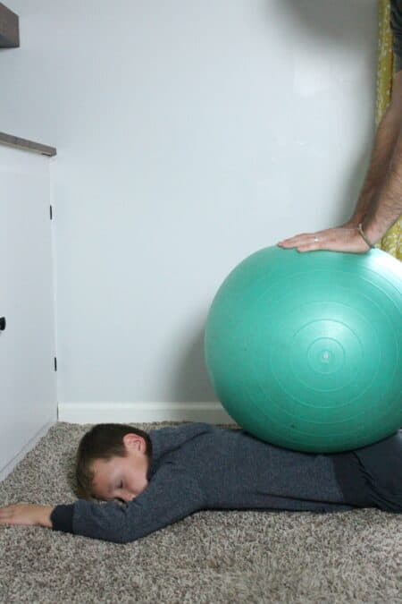

2. Make a Cross and an X: Have your child sit on top of a large enough ball so that their feet can’t touch the floor. Put your hands on their hips to help stabilize them. Then, slowly but steadily, push the ball backwards, away from you, then towards you. Next, move them from side to side. If you were looking from the top, you’d have drawn a plus sign or cross on the floor with the ball.
This activity gives lots of vestibular input and hopefully your child is adjusting their body as you move the ball in different positions so they keep their balance.
Then, you can make an X with the ball moving it diagonally.
If you’re child holds their balance well, try these motions while holding on to their thighs, right above the knee, instead of their hips, and then even more challenging, holding them by their ankles!
Check out how to do this activity in this quick video:
Powerful sensory activity with a yoga ball by your kids table
3. Bouncing Two Ways: Get your child on top of the ball and holding their hips (easiest and most secure), thighs, or ankles again, bounce them up and down on the ball. You can get silly with this, bouncing wildly, which your child may love, but it may also wind them up.
Or, you can bounce them rhythmically while counting or singing a song with a repeatable beat like “The ants go marching 1 by 1…”
The sequential bouncing is usually very calming for kids that seek out lots of movement and proprioceptive input.
Depending on your ball size, your child may also be able to sit on top of the ball and bounce themselves with their feet on the floor!
4. Follow the Trail: Simply pushing a large therapy ball around is a great heavy work activity, that means your child is working for their proprioceptive input. Pushing the ball up the wall is another way to get more sensory while adding a challenge for your child to focus on.
Adding some painters tape to the floor and even up the wall can help make the activity more engaging and give them a visual element to follow, which adds more benefit to this easy therapy ball activity.

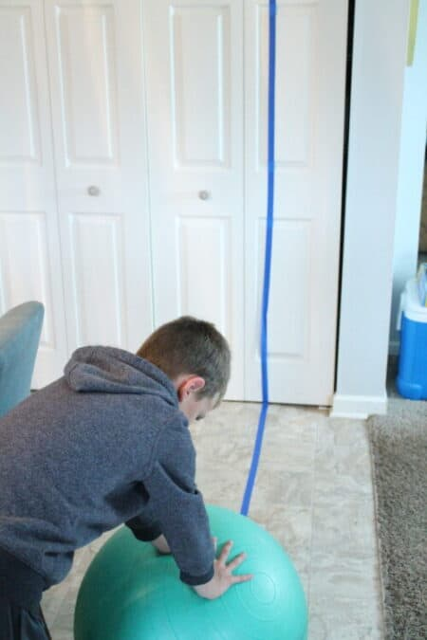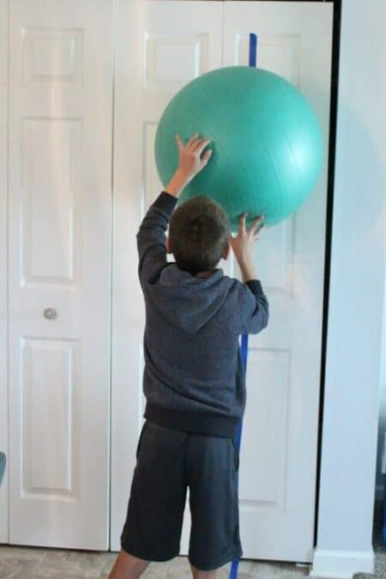
5. Big Kicks and Throws: Find an open space and kick this large ball back and forth with your child or show them how to kick it off the wall so they can do it independently. It will feel sort of silly kicking such a large ball, but it’s a whole different sensation. They’ll get a dose of tactile input too.
And, throwing will not only get them using both hands (hello, bilateral coordination), but you’ll likely get some crossing midline strengthening in there too!
6. The Wheelbarrow Walk: For this activity, hold the ball steady while your child lays across the ball on their belly. Then, roll the ball forward until your child’s hands are flat on the ground. If they are nearly vertical when you do this, your ball is too big for this activity!
When your child’s hands are flat on the ground, encourage them to “walk” forward on their hands. As they do, the ball will roll with them until just their feet are hanging on. Once they reach their feet, tell them to roll back before they fall off.
This is an outstanding sensory processing activity. Although it gives lots of propriocetive, vestibular, and tactile input, your child is getting loads of sensory processing.
7. Flipped Over: Bring your child to a sitting position on top of the ball and slowly roll the ball towards you so that they begin to tip backwards. Hold onto their hips or thighs again for that additional security. They should fall all the way backwards so that they’re hanging upside down. This is a boat load of vestibular input.
If your child is scared of heights or being tipped backward, it will take some time for them to be able to tolerate this.
Leave them their for a few seconds and roll them back up. Allow them to repeat, but carefully monitor how they’re responding.

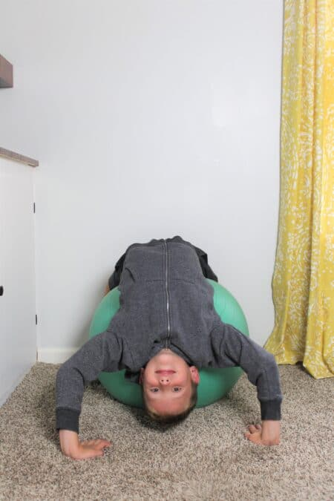
Any of these activities can be done as simply as you’ve read them here, but there’s also lots of ways to add in homework, learning, and other developmental skills to the mix. For instance, you could have a map of the follow the trail route where they find different letters to spell a hidden message or word.
Or, you could have a bucket of bean bags at the end of the wheelbarrow walk so that they grab a bean bag and bring it back to their starting point. Kids love adding these small elements and often they make the therapy ball activity a little more challenging because it incorporates additional skills.

