10 Strategies to Help children learn to communicate

Some toddlers seem to talk without any help at all. For others, we need to help a bit more. Whether toddlers have a language delay or are just learning to communicate, we are their best teachers. Talking to them, and more importantly, WITH them, can make a world of difference

- SAY THEIR WORDS
Talking about your child’s interests will make much more of an impact than talking about what we are thinking. Using short phrases, single words, and even just meaningful sounds while taking a moment to kind of jump into your toddler’s head and say HIS ideas will help your child give verbal/vocal meaning to his thoughts. Just because he is playing with a shape sorter does not mean he wants to name shapes and colors. He also may not want to ask questions. So if we are spending more time asking “what’s that?” and “where’s the circle?” then we are not giving voice to HIS ideas. He may be more interested in stacking the shapes, so say “up, up, up”; he may think it’s fun to tap the shapes together, so try “bang, bang, bang”; he may just want to toss the shapes into a bucket, so then you could say “whee” or “uh-oh” or “ready, set, GO”. Follow HIS ideas, give words to HIS play. Say HIS words.
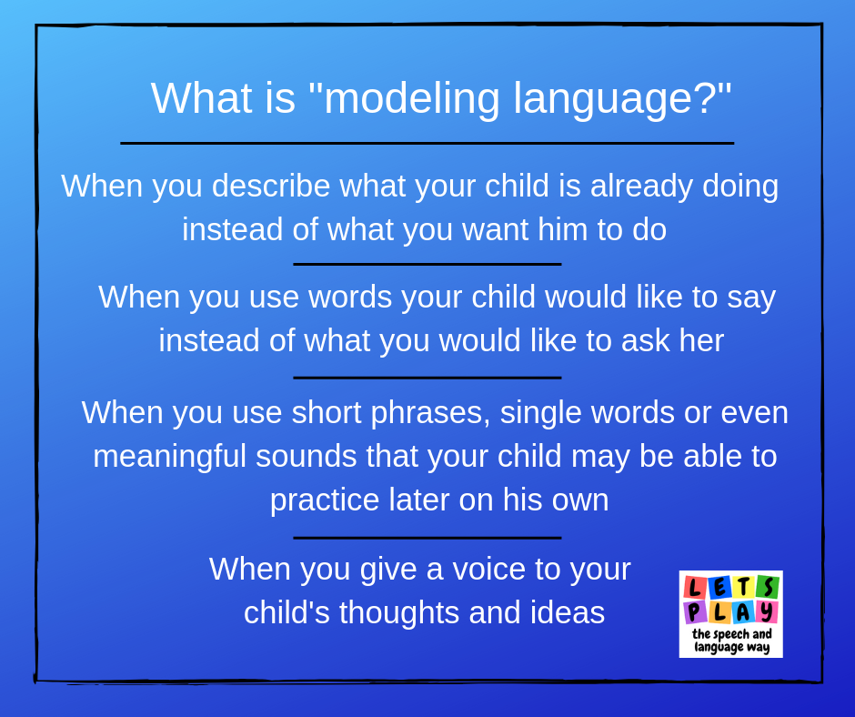

2. MAKE THE MOMENTS COUNT
The moments that your child initiates communication (showing you something, reaching for something, pointing to something) are what we, as speech & language therapists, often try to recreate during therapy sessions. However, these moments happen throughout the day and should not be missed. When your child points, name the object before you ask a question. When your child is struggling to make a decision, offer two choices. When your child grabs your hand and wants you to follow, say the word they should use to ask you to stand “up” or “come” here or “help”. Children may not be interested in repeating the same task or playing with the same toy for an extended period of time so make sure you those moments count.
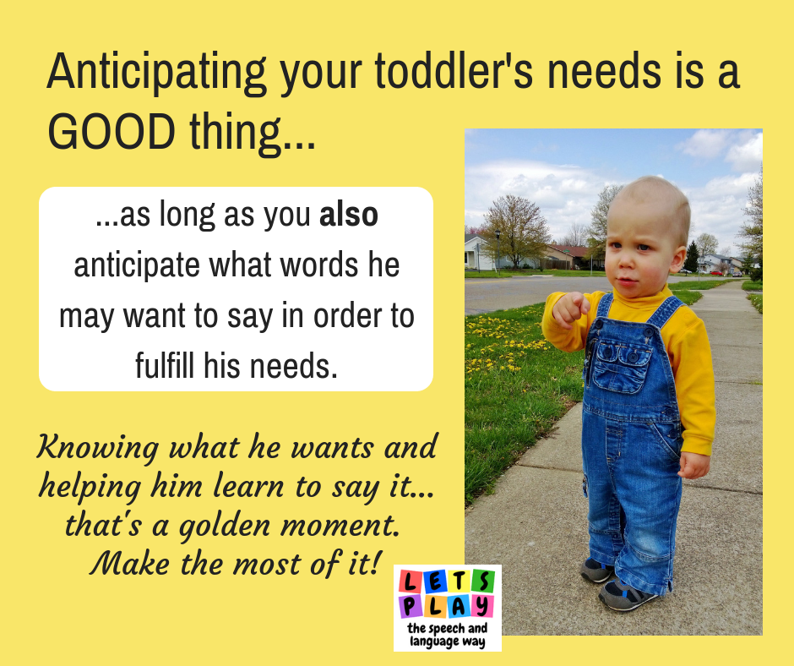

3. MAKE IT ACTIVE
Children learn to imitate and move before they learn to talk. If words are a challenge, use what they CAN do – imitate and move. Using gestures and motions with sounds allows a toddler to imitate the motion if the sound isn’t ready yet. They will feel success because they were able to do SOMEthing that you did, even if it wasn’t the word. The more success they feel (because we cheer for them) the more they may try other actions and sounds. When we greet people we say “hi” and wave. Most of the time, children will imitate the waving before they say the word “hi”. That’s perfect. Let’s do more of that. Pair the sound with an action. When you say “milk” use a Makaton sign or gesture as well. When you say “dinosaur”, try stomping your feet with the syllables “di-no-saur”. Your child may stomp back. When you say “GO…”, try patting your mouth as you hold that “oh” sound. Your child may vocalize “oh” when he imitates the motion of smacking his own mouth – ha!

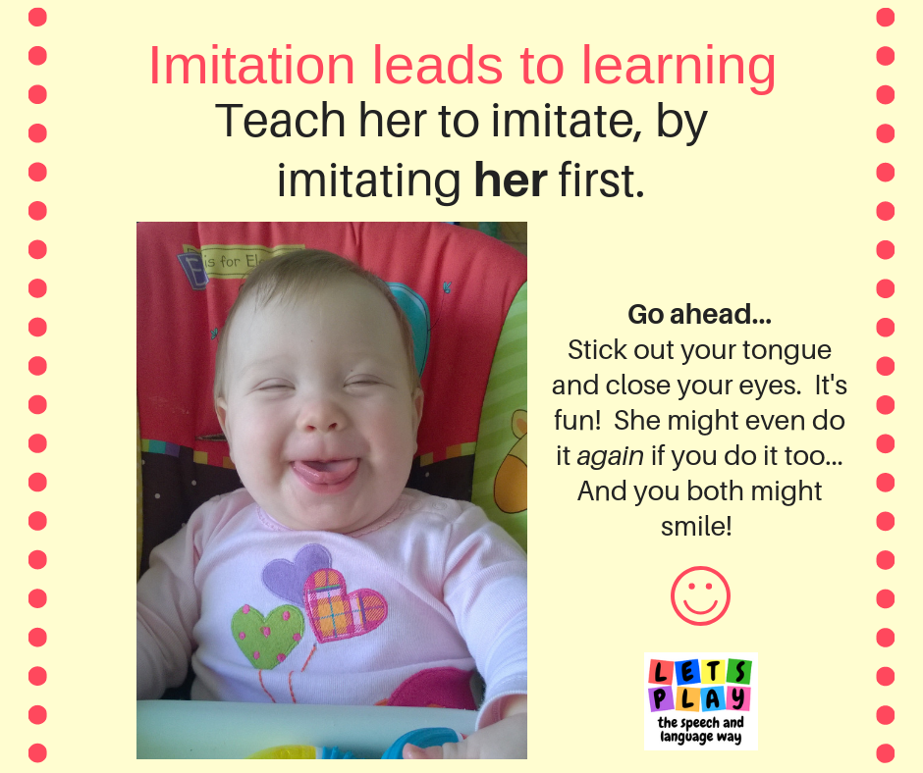

4. BETTER TOGETHER – SING AND CHANT
Doing things with others is often less intimidating than being expected to put on a solo performance. When we sing and chant and complete familiar phrases at the SAME time as our children, we give them opportunities to see our mouths move in the same way that their mouths should be moving. It’s so powerful. It’s also fun! Songs provide predictable and repetitive patterns to our words and pair those words with melody and intonation. Using familiar songs, making up your own with functional, or just chanting and completing phrases together e.g. “turn the… (page)” allows the child to practice words in the same way over and over again in a FUN way because you say them together!

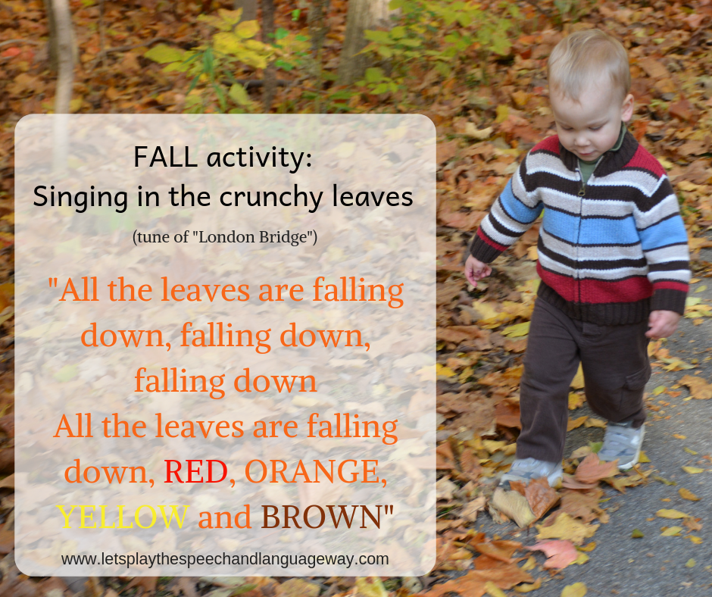

5. THIS OR THAT
When the activity options are endless or the snack cupboard is a free-for-all then making a choice can be super challenging – for anyone. Offering your child a choice of ONLY TWO options can help to limit the words needed. (It also helps limit the thinking needed to come up with an idea.) When you KNOW what your child wants, offer it as the 2nd option. For example, your child loves biscuits and you’re pretty sure that’s what she wants. Offer an obvious non-preferred choice first then the most obvious preferred choice 2nd, as in “broccoli or biscuits”. By offering the most preferred option 2nd, you’ve really just created an opportunity for your child to repeat the last word they heard rather than ALSO having to make a definite choice AND come up with the right word. That’s hard. We don’t want to make it hard. We want success! You may need to hold up the objects or pictures so that your child can visualize what the choices are. Even if they can’t yet say the words, at least they can point to their choices. You know what they want, they know what they want, and frustration may be reduced.
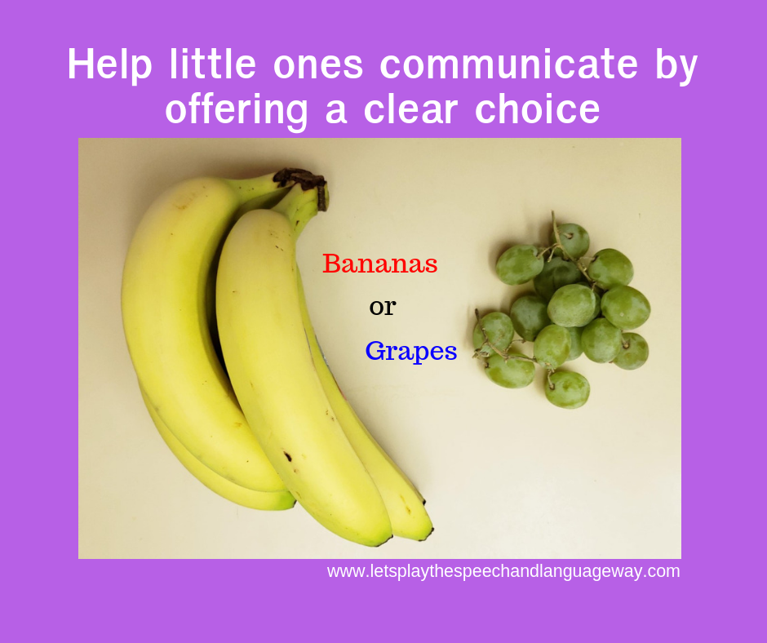

6. WATCH ME
Young children are busy. Super busy. They don’t always want to interrupt their activities in order to look at us, so we have to make it interesting and purposeful to watch our mouths move. Drawing attention to our mouth when we say single words or sounds helps her watch the movement of speech. Can’t find something? Call out to the missing object while cupping your hands around your mouth… “Daddy, where are you?” Can’t find a ball? Search for it (with purpose) “Ball?” “Ba-aaalll, where are you”. Watching how the mouth moves can also help when your preschooler needs to learn how to say specific sounds correctly. If watching your mouth isn’t high on your child’s list of importance then you may need to get creative.
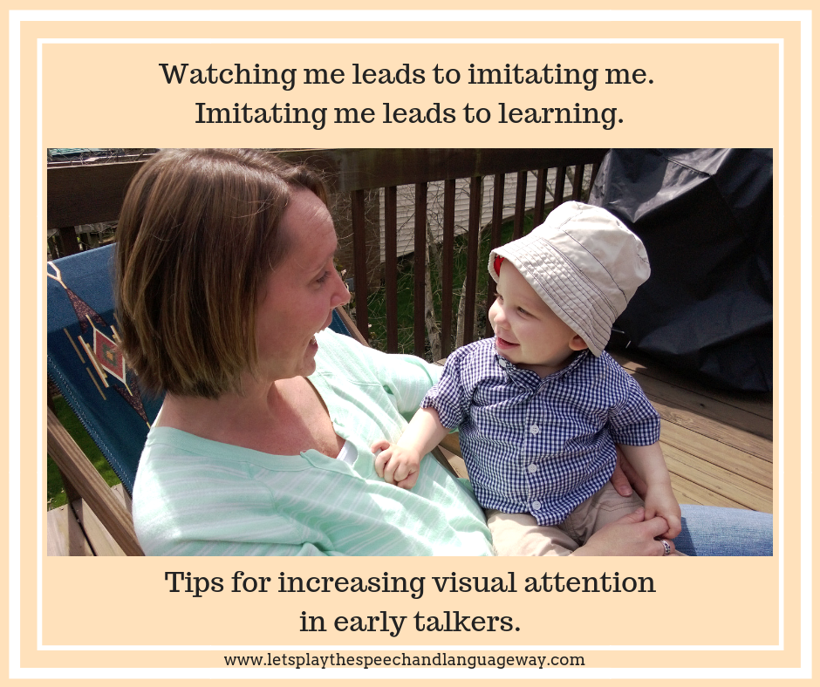

7. BREAK IT DOWN AND BUILD IT UP
When words aren’t easy, try sounds. Sometimes you may need to simplify a word down to its smallest part in order for your child to attempt it. For example, he loves dinosaurs but he never says “dinosaur”. Break it down. “Dinosaur. Dino. Di. Duh. Roar.” Offer any or all of these simplified versions of the word to see when your child is willing and able to attempt an imitation of whatever you said. Sometimes we need to go all the way down to a meaningful sound “ROAR!” No matter what level we model, we then need to help build the word back up so that, over time, your child learns to say the whole word. How about “milk”? Try “milk, mi, mmmm” or the sign for milk. Playing with sounds will ultimately help encourage a vocal child. Vocal and noisy toddlers turn into talking toddlers.
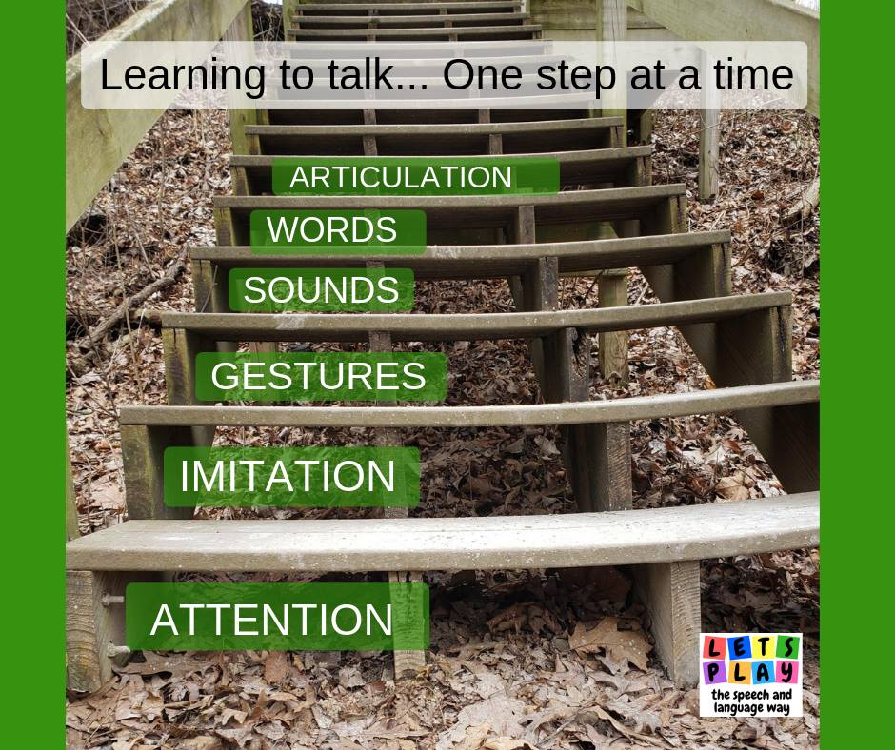

8. FORGET EVERYTHING/ SABOTAGE
Creating opportunities to talk is a favourite way of talking with young children. These early “conversations” open the door for little ones to participate, but they don’t have to. When we pretend that we don’t know where things are, or can’t remember something, then this gives toddlers their big chance to help US! For example, give a toddler his yogurt but forget to give the spoon. Give the toddler just ONE little piece of a biscuit but forget to give more. Give your child ONE shoe, but forget where the other shoe even is! (Well, maybe you don’t have to pretend with that one. Ha!) The idea is that we want to talk WITH our children, not just AT them. Asking them about their ideas or where things are or how to solve a problem, gives them opportunities to communicate. Their communication does not need to be full sentences or even with words, but at least they can participate through actions or gestures. Sometimes, the LESS you know, the more they can help!
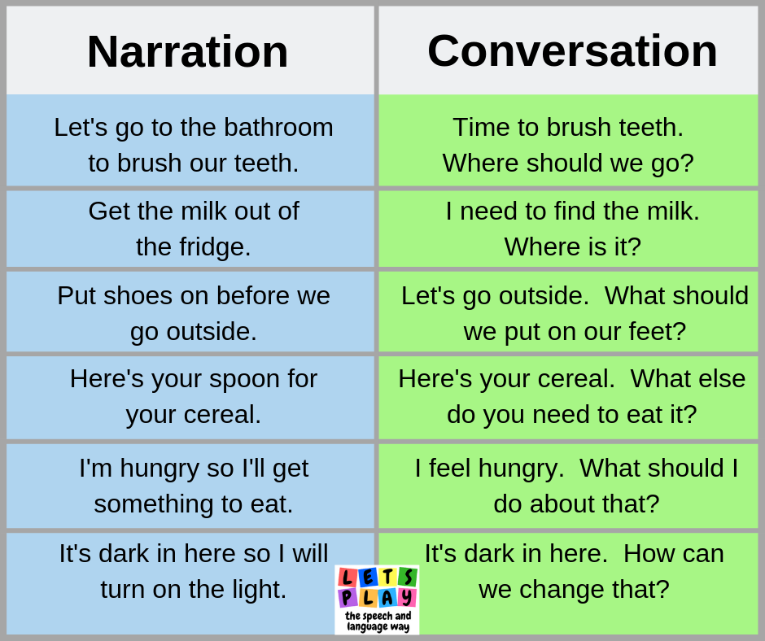

9. TAKE THE PRESSURE OFF
Taking the pressure off may be one of the most effective strategies we can use to open the doors of communication. The strategies of singing, offering choices, and being forgetful are great pressure-reducers. However, one of the favourite pressure-reducing strategies is to start with two little words: “I wonder”. Rather than ask your child “what’s this”, try wondering aloud while YOU look at the picture of the ball: “I wonder what this is.” Sounds simple and maybe you’re thinking that won’t work. Try it. Take it a step further and wonder aloud if it could be “a car? no. a bird? no.” Keep wondering “hmmmm”. Maybe even wonder aloud if it could be one of two things (this way you are reminding your toddler of the word without telling them) “I wonder if it’s a car or a ball…hmmm”. You may be surprised when your toddler tries to help you by saying “ball!” Asking direct questions and giving specific commands often feels like a test. (For example: “What color is this?” and “Say blue.”) If your child does not want to perform on demand, then it may be time to reduce the pressure and test-type questions.

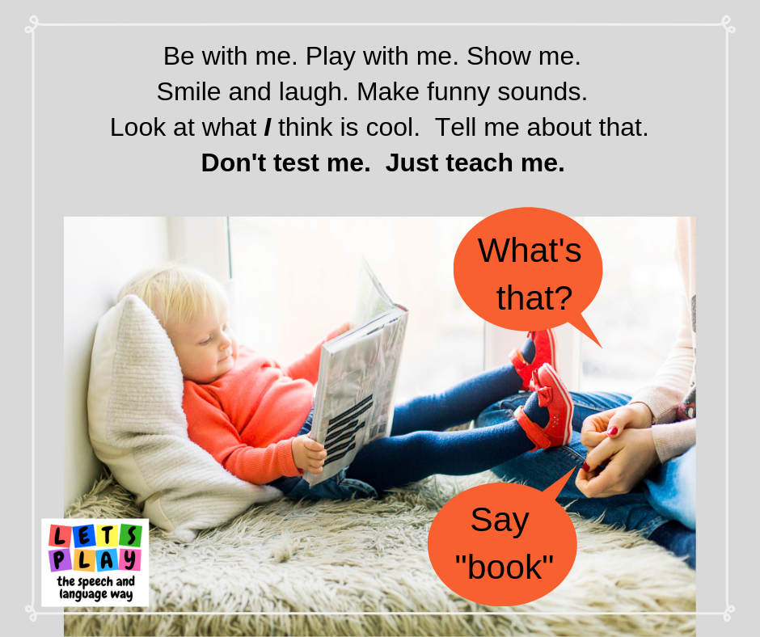

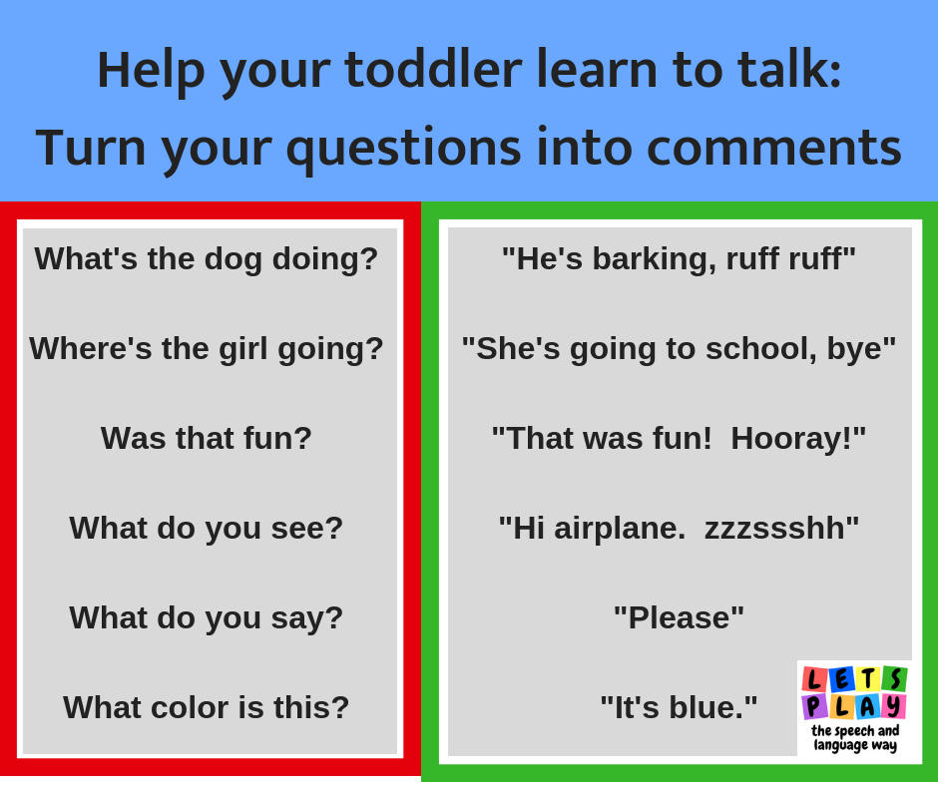

10. LEAVE THEM WANTING MORE
Your young child thinks it’s HILARIOUS to pop bubbles or play “peek-a-boo” or “tickle me” or “throw me in the air”. Whatever gets his interest, give that game a name! Then wait. Wait. Wait some more. Wait until HE gives you some indication that he wants it to continue. He may smile, he may search, he may reach, he may look at you… whatever it is – WAIT for it. When he indicates the game needs to go on – NAME it or say “more” or “again”! The more we continuously entertain our children without waiting for their requests, the more we have missed opportunities to help them communicate! Make those anticipatory silly faces, hold those toy cars at the starting line, get your hands in the tickle position, pucker your lips to blow some more bubbles…but DON’T. Give your child the chance to tell you “ready, set… GOOO!”
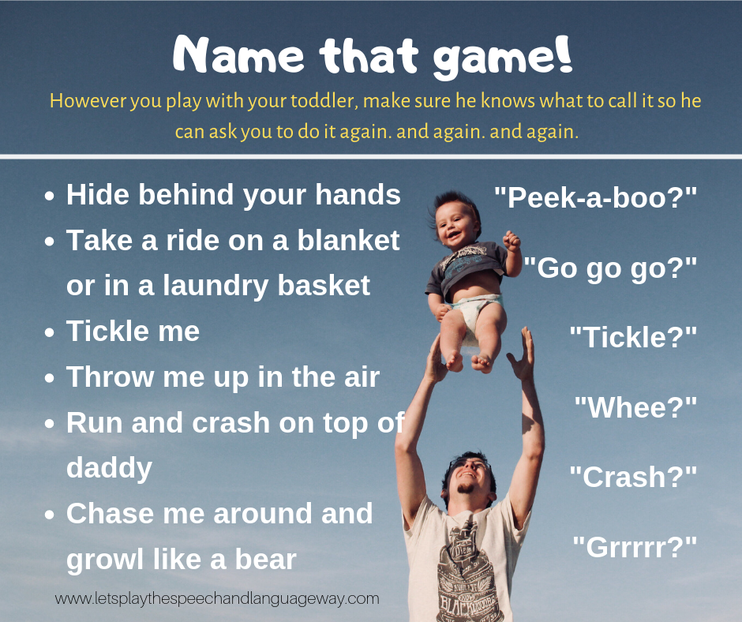
So, there’s the “10 strategies” list. It’s not “top 10” or “10 best” because there are so many strategies that are helpful. Many overlap. Some need to be combined. Some are better suited for specific activities. Some work better than others depending on the child and the caregiver. The bottom line is that HOW you talk WITH your child can make a huge impact. No toy or app can ever replace a human being when it comes to learning to communicate. You don’t need to master ALL of these strategies, but if you try a few you may be glad you did! You’ll know you got it right because your child will let you know (with words or a smile).

Strategies taken from the www.Letsplaythespeechandlanguageway.com

Other useful links www.hanen.org

