MCA Form 7 Workshop
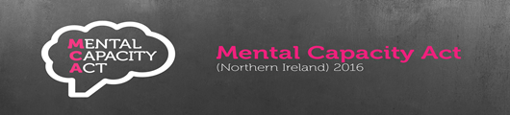
Date: Wednesday 7th September 2022 Time: 1.30pm – 4pm
Venue: Banbridge Enterprise Centre
Scarva Road Industrial Estate,
Scarva Rd,
Banbridge
BT32 3QD
This workshop aims to support staff involved in completing statement of Incapacity (Form 1) & DOL Applications (Form 5) to;
- Understand the legislation and referral processes to the Review Tribunal & why we notify the Attorney General
- Reflect on Form 7 referral rates & explore Case law reviews in respect of Form 7 referrals
- Consider and understand who needs a Form 7 and when they need it

Opportunity for questions, answers and open discussion will also be available


Should you wish to attend this workshop please complete the attached application form and return to tessa.murphy@southerntrust.hscni.net
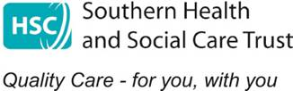

MCA COURSE APPLICATION FORM
Title of Course:
Date of Course:

Please ensure all contact details are completed to facilitate timely
communication in the event of any changes

Name
Job Title
Staff Discipline (e.g. Social Services)
Staff No (Trust Staff only)
Email address
Tel Number
Sector (i.e. Trust, Independent sector)

Please return completed from to:

tessa.murphy@southerntrust.hscni.net

