MCA Best Interests & Care Planning Workshop
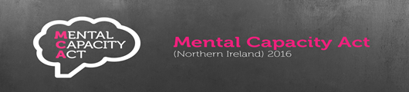
Date: Tuesday 22nd November 2022 Time: 9.30am – 12.30pm
Venue: WIN Business Park
Canal Quay
Newry
This workshop aims to support staff involved in completing Best Interest statements (Form2) & Care Plans (Form 4) for MCA DoL applications to;
Develop their knowledge and understanding of the concepts of “Best Interest” including:
  - Special Regard
  - Nominated Person
  - Prevention of Serious Harm
  - Less Restrictive Options
  - Care & Treatment

Understand the importance of these key concepts in the context of the relevant safeguards of the MCA (NI) 2016.
There will be opportunity for questions, answers and open discussion 
Should you wish to attend this workshop please complete the attached application form and return to tessa.murphy@southerntrust.hscni.net



MCA COURSE APPLICATION FORM
Title of Course:
Date of Course:

Please ensure all contact details are completed to facilitate timely
communication in the event of any changes

Name
Job Title
Staff Discipline (e.g. Social Services)
Staff No (Trust Staff only)
Email address
Tel Number
Sector (i.e. Trust, Independent sector)

Please return completed from to:

tessa.murphy@southerntrust.hscni.net

