MCA Nominated Person (NP) Workshop
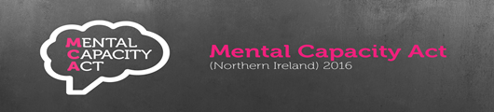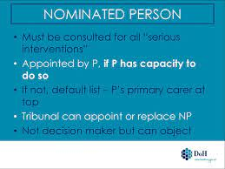
Date: Tuesday 15th November 2022 Time: 2pm – 4pm
Via: Zoom
Link: https://southerntrust-hscni.zoom.us/j/89984610883?pwd=RktkTjRYYVNPUmU5N0RIbDIvc29VUT09
(Meeting ID: 899 8461 0883 Passcode: 41423644)
This workshop aims to support staff involved in completing Statement of Incapacity (Form 1), Best Interests Statements (Form 2) & DOL Applications (Form 5) to;
- Understand the legislative requirements in relation to the appointing of a Nominated Person (NP) within the DoL process
- Reflect on how we prepare and support the NP in understanding the expectations placed on them
- Consider the importance of this role and where it fits within the MCA Safeguards and Principles
- Explore how staff can address/ manage issues such as revoking or changing the NP within the DoL process

Opportunity for questions, answers and open discussion will also be available

Should you wish to attend this workshop please complete the attached application form and return to tessa.murphy@southerntrust.hscni.net
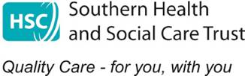

MCA COURSE APPLICATION FORM
Title of Course:
Date of Course:

Please ensure all contact details are completed to facilitate timely
communication in the event of any changes

Name
Job Title
Staff Discipline (e.g. Social Services)
Staff No (Trust Staff only)
Email address
Tel Number
Sector (i.e. Trust, Independent sector)

Please return completed from to:

tessa.murphy@southerntrust.hscni.net

