MCA Review Tribunal and Oral Hearing Workshop
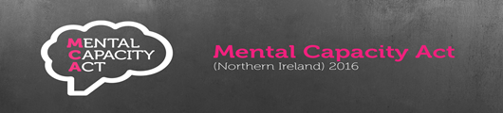
Date: 18th October 2022
Time: 2pm – 4pm via Zoom
Aims and Objectives:
- Support staff involved in MCA DoL applications where the Review Tribunal is involved to develop their understanding and knowledge.

- Opportunity will be offered to participants to gain useful insight into the purpose and role of the Review Tribunal within MCA and purpose of subsequent Oral Hearings.

- Participants will also have the opportunity to hear first-hand experiences form staff who have been directly involved in Oral Hearings and learning gained form this.

- Opportunity for questions, answers and open discussion will also be available


If you wish to attend this zoom session, please complete the application form below and forward to; tessa.murphy@southerntrust.hscni.net

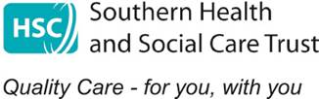

MCA COURSE APPLICATION FORM
Title of Course: MCA Review Tribunal and Oral Hearing Workshop

Date of Course: 18th October 2022

Please ensure all contact details are completed to facilitate timely
communication in the event of any changes

Name
Job Title
Staff Discipline (e.g. Social Services)
Staff No (Trust Staff only)
Email address
Tel Number
Sector (i.e. Trust, Independent sector)

Please return completed from to:

tessa.murphy@southerntrust.hscni.net

