 APPENDIX 4

Dear
Thank you for showing interest into volunteering within the Southern Health & Social Care Trust. Below is the Volunteer Registration Form. However, we would ask you to take a few minutes to contemplate the following points before beginning to register as a volunteer with us.

Important points to consider:
- Registering to become a volunteer can take over 6 weeks to complete
- The Trust commits to fund the registration and training of each volunteer. Therefore, we ask you to commit from 6-9 months volunteering with us.
If you are unable to commit to this there are other shorter term opportunities which you can check out with Volunteer Now via www.becollective.com.
If you can fulfil the terms above then we encourage you to complete the registration form below and email or post it back to the volunteer coordinator covering your geographical area. All our details are below. We will then send out the application for an Access NI check. You will find the details of the registration process are listed below.
Kind regards

Volunteer Co-ordinator

Craigavon & Banbridge  Aine Mulholland  Tel: 028 3756 3950  aine.mulholland@southerntrust.hscni.net | Newry & Mourne  Katrina Lavery  Tel: 028 3756 6295  katrina.lavery@southerntrust.hscni.net | Armagh & Dunagnnon  Karen McCabe  Tel: 028 3856 4498  karen.mccabe@southerntrust.hscni.net

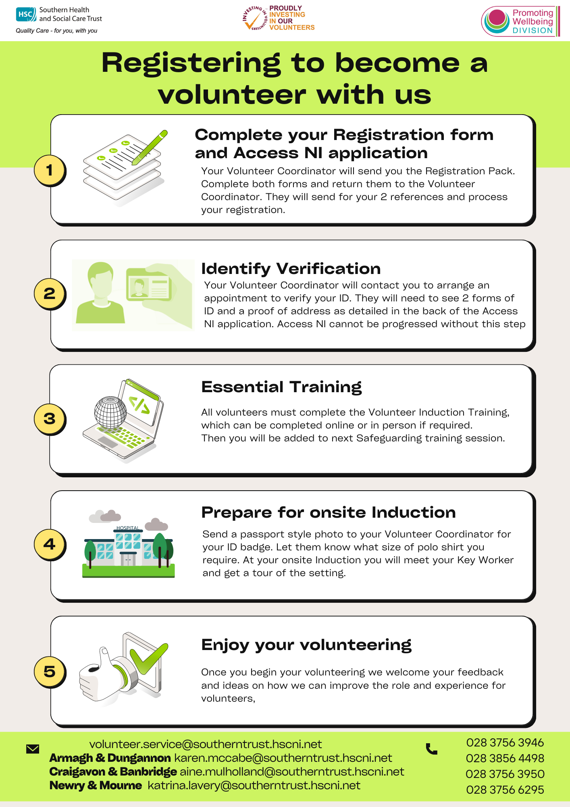

Volunteer Registration Pack

By completing this registration form, you will assist us to find the best placement for you. If you have any difficulties with the form, please ask for assistance. The details will be treated confidentially and will only be passed to the placement provider with your permission. The information we collect is gathered in accordance with GDPR and the Data Protection Act 2018.

Full Name:
Maiden Name/Previous Surname(s):

Date of Birth:

Address:
Town;
Postcode:

Contact Phone Number:

Email Address:

National Insurance number;

Next of Kin Name and Contact Number:

Please give a brief description of your background, including skills and qualifications you might wish to use in your voluntary work. You may wish to include previous/current experience of employment/ voluntary work/ training/ caring responsibilities.

Please indicate when you are available to volunteer
 | Mon | Tues | Wed | Thurs | Fri | Sat | Sun
Morning
Afternoon
Evening
Please tick to indicate which of the following settings you would be interested to volunteer in.
Hospital Setting |  | Driving
Learning Disability |  | Befriending
Physical Disability |  | Day Centres
Older People |  | Supported Living
Children |  | Other specify

References:
Please name 2 persons (not a family member and who is known to you for at least 2 years) who have agreed to act as referee on your behalf. If you have been employed before, you must include the details of you former employer.
 | Reference 1 | Reference 2
Name

Address

Postcode

Telephone

Email

Occupation

Do you have a driving licence? Do you have access to a car?
Yes / No Yes / No

Pre Placement Health Screening Form

The purpose of this section is to ensure that you are informed about protection against infectious diseases such as TB and measles. If you answer yes to any of the questions can you please provide your National Insurance number, as we may refer you to an Occupational Health Practitioner for further advice and follow up.

1 | Do you need any specific aids/adaptations /adjustments to assist you with your volunteer role? | Yes | No | If yes, Please provide details
2 | Do you have any serious allergies? | Yes | No | If yes, Please provide details
 | In relation to potential exposure to TB:
3 | Have you lived or worked in a country outside UK and Ireland for more than 3 months in the past 5 years? | Yes | No | If yes, Please provide details i.e. where and when
4 | In the past 12 months have you had a cough for more than 3 weeks / unexplained weight loss, fever / night sweats or been in contact with someone with TB? | Yes | No | If yes, Please provide details
5 | The following information relates to protection against infectious diseases such as measles or rubella:  • If you were born before 1970 you are likely to have acquired natural immunity against measles, no further action is required.  • If you were born after 1970 and have received two doses of MMR you are protected against measles and rubella, no further action is required.  • If you were born after 1970 and are unsure if you have received both doses of MMR/MR vaccines, you can contact your GP or school health records to obtain this information:  It is important to protect yourself, your families and vulnerable patients, who you may come into contact with as part of your volunteering role against infectious diseases such as measles and rubella. The best way to do this is to ensure you have received two doses of MMR/MR. If you are unclear or unaware that you have had both doses you can receive MMR vaccination through your GP or the Southern Trust’s Occupational Health Service would be happy to assist with this.

Disability
The Disability Discrimination Act 1995 defines disability as a physical or mental impairment which has a substantial and long term effect on a person’s ability to carry out normal day to day activities. Normal day to day activities are outlined in the Act as those activities which affect one of the following broad categories of capacity; mobility; manual dexterity; physical co-ordination; continence; ability to lift, carry or otherwise move everyday objects; speech, hearing or eyesight; memory or ability to concentrate, learn or understand; or perception of risk of physical danger.
If you have a disability in line with this definition and require reasonable adjustment for the voluntary work you wish to be considered for, the Trust/Organisation would be keen to discuss this with you to agree what can be accommodated. Having read this definition do you require a reasonable adjustment for reasons related to a disability to allow you to undertake voluntary work?
Yes / No* *Delete as appropriate
If you have answered yes to the above question on disability, a meeting will be arranged with you to discuss the reasonable adjustments required. To inform this discussion please provide details below of the reasonable adjustments required so that this may be fully considered.

Criminal Record
The HSC is committed to equality of opportunity for all volunteers, including those with criminal convictions. Whilst the disclosure of information does not automatically debar an individual from volunteering, it is essential that all convictions are disclosed to allow the Trust to adequately consider their relevance to the volunteer role in question. We will undertake to ensure an open, measured and recorded discussion on the subject of any offences and other matters that might be considered relevant for the volunteer role concerned. The HSC considers failure by individuals to declare complete and accurate information about convictions to be a serious breach of trust.
Below you are asked to disclose any criminal convictions or offences. The role to which you have applied falls within the definition of ‘excepted employment’ as provided by the Rehabilitation of Offenders (Exceptions) (NI) Order 1979 which provides additional protection to vulnerable groups and applies to all posts within the Health and Social Care Services. Under this Order, no conviction is ever regarded as spent. The only exception to this is protected disclosures as detailed in the Protection of Freedoms Act 2012.
Therefore you MUST disclose information about ALL cautions and convictions, even where they are ordinarily considered as “spent” (other than protected disclosures). You should also include any pending charges. For motoring offences see next section. In this regard please answer the following questions.
 | Yes | No
Have you ever been convicted, charged, prosecuted, cautioned or bound over for any offence, no matter how minor?
Are you currently the subject of a police investigation or do you have any prosecutions pending?
If you have answered yes to any of the above questions, please provide details below. It is important that you list ALL charges, prosecutions, convictions, cautions, bind-over orders (other than protected disclosures) – even if they happened a long time ago.
Date of conviction/charge/  Prosecution/caution/bind over | Offence | Penalty/Sentence received

Other Offences
Here you should state offences which are not criminal offences but must be declared to ensure the Trust has full information of any offences you have, or have been charged with. For example minor motoring offences which you have not attended court over such as fixed penalty notices should be listed below.

Date of Offence | Offence | Penalty received

Safeguarding Vulnerable Groups (NI) Order 2007 as amended by the Protection of Freedoms Act 2012
Under the, the Trust/Organisation must not involve a volunteer in regulated activity who is barred from such activity.
 | Yes | No
Are you currently barred from Regulated Activity by the Disclosure & Barring Service?
Are you currently referred for investigation to the Disclosure & Barring Service?



Volunteer Consent

I do / do not* give permission for my photograph to be used in the Southern Trust literature e.g. Annual Report for Volunteering, photo loop at Volunteer Recognition events, internal e-briefs to Trust staff, Trust social media platforms and newspaper publications. (*Please delete as appropriate) Not consenting in no way affects your volunteering opportunity.

Print Name
Signed
Date:

You have the right to withdraw consent at any time but there will be limitations to our ability to remove any images that have been published on the internet by newspapers or on social media.

Parent/ guardian consent (if under 18)
Name of Volunteer:

The above named has applied to become a volunteer with the Southern Health and Social Care Trust. As the above named person is under 18 years of age, we require the consent from a parent/guardian before any volunteering can commence. Therefore, it would be appreciated if you would complete the slip below and return it in the envelope provided.
Please note that should a volunteering role involve having substantial access to children and /or vulnerable adults, a criminal record check has to be carried out by the police before any volunteering can commence.

------------------------------------------------- * has/has not my permission to become a volunteer with the Southern Health and Social Care Trust.
*Please delete as appropriate

Signature: Date:

For Volunteers who use their car to carry out their role (e.g. volunteer drivers, mentors or befrienders who may carry service users in their car)

Please complete and sign the statement below if applicable to the volunteer role you are registering for:

1. I have a clean current Driving Licence and my Car Insurance Policy is endorsed to cover the use of the car for official business connected with voluntary driving. I have informed my Insurance Company of the nature of the work being undertaken and it accepts the insurance liability.

2. I agree to produce my current Driving Licence and Car Insurance Policy to the Key Worker/Head of Department before I am permitted to undertake any voluntary driving tasks on behalf of the Southern Health & Social Care Trust.

3. I am prepared also to keep accurate mileage records as required and to submit monthly returns to the Key Worker

Consent and Declaration of Accuracy

I understand, depending on where I undertake my role that a criminal record check with the police may be carried out before my appointment can be confirmed and I am aware that spent convictions may be disclosed. I am also aware that I will have to undertake a health check before commencing volunteer work within the Trust. I declare that the information I have given is accurate and I consent to the police check being made.

Signed:

Date:

Equality and Diversity Monitoring Private & Confidential

The Southern Health and Social Care Trust wishes to ensure its services are accessible to everyone.
Whilst the completion of this monitoring form is optional, the Trust would appreciate your co-operation to enable it to monitor and evaluate that involvement in decision-making processes.

Section 75 of the Northern Ireland Act 1998 requires us to promote equality of opportunity on the basis of nine categories which informs the questions we ask:

Access to any information supplied will be strictly controlled by the trust

(1) Age Range: Please tick the age category to which you belong:

16 – 29 30 – 44 45 – 59 Over 60

(2) Gender: Male Female

(3) Marital Status: Single Married/Civil Partnership Other

(4) Community Background:

I am a member of the Protestant community
I am a member of the Roman Catholic community
I am a member of neither the Protestant nor the Roman Catholic community
(5) Religious Belief: Please indicate if you practice a particular religion by ticking one box.

Buddhist Christian Hindu Jewish Muslim Sikh
None Other

(6) Ethnic Group: To which of these ethnic groups do you consider you belong?

Bangladeshi Black African Black Caribbean
Black Other Chinese Filipino
Indian Irish Traveller Mixed Ethnic Group
Pakistani White Other

(7) Nationality: (British, Irish, Polish, Filipino… please specify)

________________________________

(8) Do you have caring responsibilities for: (tick each box that applies to your circumstances)
a child (or children)
a dependent older person
a person(s) with a disability
none of the above

(9) Disability:

Disability is defined as a physical or mental impairment which has a substantial and long-term adverse effect on the individual’s ability to carry out normal day-to-day activities.

NB: When responding to this question, please do not take into consideration any medication, treatment or prostheses that help you manage your condition (with the exception of glasses or contact lenses).

Having read the above definition, do you consider yourself as having a disability?
Yes No
If yes, please indicate which type of impairment(s) apply to you: (please tick all that apply to you)
- Long standing illness, such as cancer, HIV, diabetes, chronic heart disease or epilepsy
- Learning disability, such as Down’s Syndrome, Dyslexia or Cognitive Impairment such as Autism
- Mental health condition, such as depression or schizophrenia
- Physical Impairment, such as difficulty using arms or, mobility requiring a wheelchair or crutches
- Sensory Impairment, such as blind/visual impairment or deaf/hearing impairment
- Other

- Sexual Orientation: My sexual orientation is towards someone:
Of the opposite sex Of the same sex
Of the same sex and of the opposite sex I do not wish to answer

- Political Opinion: Please tick the appropriate box to indicate your political opinion.
Broadly Nationalist Broadly Unionist
Other I do not wish to answer

Thank you for your co-operation

Please return Equality & Diversity Monitoring in the separate envelope

