February 2019 Recipe of the Month

Bulgur wheat with red pepper and herbs

Serve up a surprise with these delicious grains, bursting with Mediterranean flavours
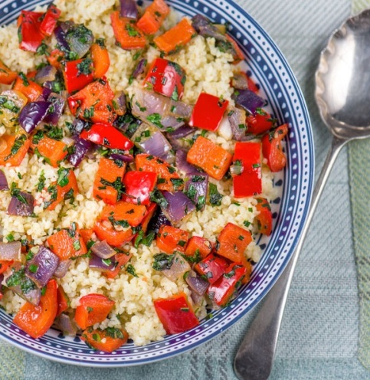


#realrecipes

Recipe by: Sharon Hui |Health Information Manager Bulgur wheat is a versatile wholegrain that's great at absorbing flavours. This dish is a perfect accompaniment to grilled fish or chicken, or you could simply serve it with steamed vegetables for a lighter meal.

Ingredients Time: 25 minutes
150ml vegetable stock (reduced salt or home-made) Serves: 2
100g bulgur wheat Calories: 272 kcals
1 tablespoon olive oil Fat: 6.9g
1 red pepper, diced Salt: 0.1g
1 shallot, finely chopped Sugar: 4.4g
1 clove garlic, crushed 5 a day: 1
1 tablespoon chives, finely chopped
1 teaspoon fresh basil, finely chopped
1 teaspoon fresh oregano, finely chopped
Freshly ground black pepper

Method
- Bring the stock to the boil in a small saucepan, add the bulgur wheat and cook for 10–15 minutes, until the stock has been absorbed and the bulgur is tender.
- A few minutes before the bulgur is done, heat the olive oil in a non-stick pan over a medium heat and sauté the pepper and shallot for 4 minutes.
- Add the garlic and herbs and sauté for 1 minute more.
- Pour the mixture over the bulgur. Mix well, season to taste with black pepper and serve
Recipe from: https://www.wcrf-uk.org/uk/recipes/bulgur-wheat-red-pepper-and-herbs
Feedback and comments to: cookit@southerntrust.hscni.net

