Calling all over 50’s!
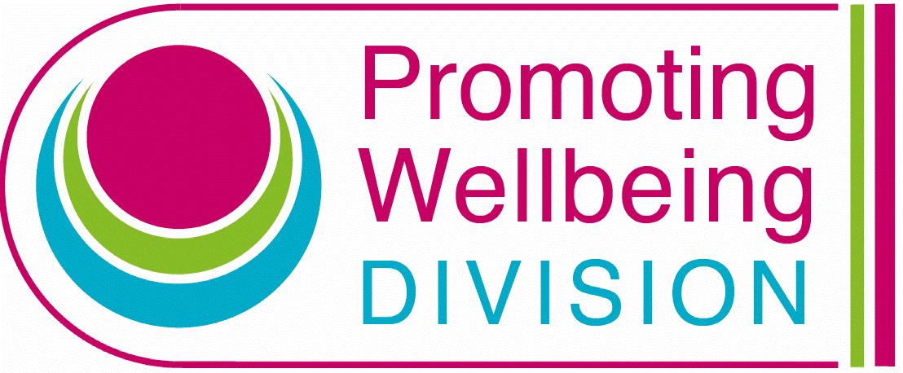

Movement for Life Photo Competition


The Southern Trust in partnership with local Councils is launching a Movement for Life competition to capture and celebrate positive images of over 50’s being active, to form a Trust wide physical activity campaign. The overall campaign is aimed at increasing awareness of moving and the huge benefits of being active.
We want to hear from you… send us your photo and a quote highlighting why moving matters to you? Be part of a physical activity campaign designed and produced by over 50’s in the Southern Trust celebrating being strong and active.

How do I enter?
- Submit your image of at least one person aged 50 and over being active saved as a JPEG.
- Provide a few lines on why moving matters to you or the group.
- Add your name/group name, location of photo and type of activity to your application.
- Please seek consent from subjects within photo prior to submission.
- Send you image to physical.activity@southerntrust.hscni.net
- Closing date for applications is Friday 31st May 2024
- For more information contact email: physical.activity@southerntrust.hscni.net or phone Wendy on 028 3756 6175.

Prizes
1st prize: £100 All 4 One Gift Voucher
2nd Prize: 3 x £50 All 4 One Gift Voucher

Selection and judging
All images and quotes will be judged by our physical activity over 50’s focus group.
Consent:
By submitting an image and quote you are providing consent for us to use the image as part of the wider Movement for Life campaign. Please seek consent from all individuals within the image prior to submission. All images will be used publically.

Competition opens: Wednesday 1st May 2024
Competition closes: Friday 31st May 2024
Please return images and quotes to physical.activity@southerntrust.hscni.net by Friday 31st May 2024

Competition rules and submissions:
The competition is open to professional and amateur photographers.
All images must feature one or more adults aged 50 or over, being active.
Only one image can be submitted per person or group.
All images should be submitted with a few lines highlighting how moving matters to you or your group.
Photographers must have consent from subjects within the image prior to submission to the competition.
All images should include individuals or groups of people who are 50 and over who reside within the Southern Trust area only.
Photographs can be copied, modified, or distributed without asking permission from the creator / photographer.
Images will be shared and promoted across social media, websites, posters, display screens and flyers across agencies such as Trust, Public Health Agency, Councils and Community & Voluntary sectors as part of a regional/local physical activity campaign.
Images of recognisable individuals are classed as personal data and will be treated as such.
Images will be used in any and all media formats – print, online, social.
Images should be saved as a JPG file format with a maximum size of 10 megabytes.
Photographers are asked to submit their entries by email to:physical.activity@southerntrust.hscni.net
If you require support to submit your entry online, please contact: physical.activity@southerntrust.hscni.net or call Wendy on 028 3756 6175
The Movement for Life Competition is funded by the Public Health Agency and coordinated by Physical activity Lead, Clare Drummy SHSCT.

