Contact Details

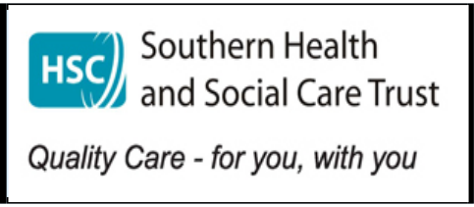
Single Point of Entry Gateway Service
Gateway Service for Children’s Social Work
For all new referrals, enquiries or information contact the Single Point Of Entry
Gateway Service:

Tel: 028 3756 7100
Or Freephone (from landlines only): 0800 7837745

Lisanally House, Lisanally Lane Armagh BT61 7HF
Tel: 028 3756 7100

Freephone (from landlines only)

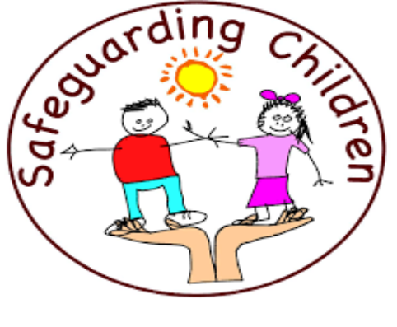
0800 7837745

Email: duty.service@southerntrust.hscni.net

For Referrals Out of Hours Regional Social Work Service 028 9504 9999

A Duty Social Worker is available to take your call Monday to Friday from 9.00am—5.00pm (excluding Public Holidays



The Purpose of Gateway

What is Gateway?
•

•

•
To work in partnership with children and families to assess their needs and to identify appropriate support services. To ensure an immediate response to safeguard children in need of protection.
To ensure that everyone involved with a child can make a meaningful contri- bution to the assessment of the child
and his or her family.
•

•
•

•

•

•
We provide a Social Work Service; Monday to Friday from 9.00am - 5.00pm.
We provide information and advice.
We visit and speak to children, young peo- ple and their families in their own home; to assess what they need.
We speak to other professionals involved with the family to ensure their views are included in the assessment.
We refer families to locally based services for additional support when needed.
We keep families and professionals
informed throughout the assessment.
•

•

•

•
We aim to allocate all referrals within 20 working days and complete all initial as- sessments within 10 working days.
We give the family and professionals (when appropriate) a written copy of the completed assessment.
We ensure families and professionals know what happens next.
We ensure children and families who continue to need a social work service are
transferred to their local social work team.
- To identify children/young people who need ongoing social work involvement and to pro- vide this for them.
- To work closely with other agencies when there is a concern about a child/young per- son or when additional support is needed.
- To make sure that all new referrals are responded to promptly.
- Gateway is a social work service for children and families.
- It is the first point of contact for people who wish to share a concern about a child/young person who is not already known to Social Services.
- It exists to respond quickly to the needs of children and families who are referred for a Social Work Service.
What do we do?
The Purpose of Gateway

