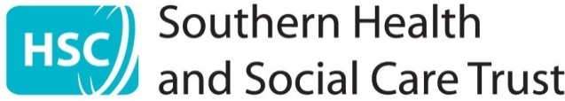

COVER SHEET

Meeting and Date of meeting | Trust Board  21 November 2024
Title of paper | Cervical Cytology Review Update
Accountable Director | Name |  | Dr Stephen Austin  Cathrine Reid
Accountable Director | Position |  | Medical Director and Director Surgery & Clinical Services
Report Author | Name |  | Denise Newell
Report Author | Email |  | Denisee.newell@southerntrust.hscni.net
This paper sits within the Trust Board role of: |  |  | Accountability
This paper is presented for: |  |  | Assurance  (Notes on completion at end of document)
Links to Trust Corporate Objectives | ☒ | Promoting Safe, High Quality Care
Links to Trust Corporate Objectives | ☒ | Supporting people to live long, healthy active lives
Links to Trust Corporate Objectives | ☒ | Improving our services
Links to Trust Corporate Objectives | ☒ | Making best use of our resources
Links to Trust Corporate Objectives | ☐ | Being a great place to work – supporting, developing and valuing our staff
Links to Trust Corporate Objectives | ☒ | Working in partnership

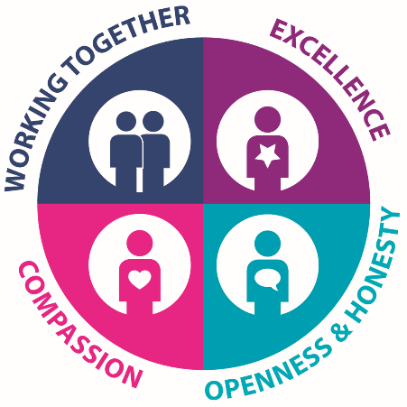 | The report author will complete this report cover sheet fully. The Accountable Director must satisfy themselves that the cover sheet is accurate and fully reflects the report. The expectation is that the Accountable Director has read and agreed the content (cover sheet and report).  Its purpose is to provide the Trust Board/Committee with a clear summary of the report/paper being presented, how it impacts on the people we serve and the key matters for attention and the ask of the Trust Board/Committee

- Reason for Presentation of Paper / Report
To provide an update on the progression of the Cervical Cytology Review.
- Detailed summary of paper contents:
Summary
The Cervical Cytology Review has considered the cases of 17543 women based on the findings of the RC Path Report. This was done by collaborative work between the Southern Trust, the PHA, Western Trust, Northern Trust and Belfast Trust to deliver the slide review and call forward smear.

Cytology Slide Review Pathway
The slide review pathway has been completed for all women, including the addendum slide review.

Call Forward Pathway
As of 14 November 2024, the Call Forward pathway is essentially complete with only 16 women awaiting the completion in this pathway for individual reasons.

Outcomes Report
A comprehensive Outcomes Report is being drafted. This complex report will describe in detail the methodology of how the review was undertaken and will describe the full factual findings arising from the Cervical Cytology Review

- Areas of improvement/achievement:
- The Cervical Cytology Review is essentially complete (bar the small number of women due to individual issues as noted above).

- Areas of concern/risk/challenge:
- Ongoing media interest in this subject matter.
- Communication of complex information to the range of the different stakeholder and interested parties – including the public, media and interested parties while recommendations are being actioned.

- Impact on Statutory Duties: Provide details on the impact of the following and how.
Financial Impact |  |  | Safety and Quality Impact
- Yes, there are Financial Impacts  - Cost of performing the review |  |  | Yes, there are Quality, Safety or Experience Impacts
- Risk Assessment (Risk level and state if a risk assessment be completed)
Clinical Risk
- Potential for delayed cervical cancer diagnosis and therefore, delayed treatment
- Reputational risk
- Loss of public confidence
- Organisational risk
- Potential litigation
Currently, the risk assessment is rated as a medium taking into account the mitigations in place.
- Other Business Intelligence/data (If appropriate)
- Impact: Provide details on the impact of the following and how. If this is N/A you should explain why this is an appropriate response.
Corporate Risk Register | Risk to safe high quality care due to delay in timely intervention to prevent cervical cancer as a result of historic underperformance issues in cervical cytology screening.
Board Assurance Framework | Updates to Trust Board, Governance Committee and SLT.
Equality and Human Rights |  | This issue will impact the female population in the Southern Trust area with a review of the results of the slides screened fully or in part by the screeners for whom concerns had been raised for the period from 1 January 2008 and October 2021.

