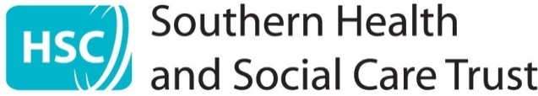

TRUST BOARD COVER SHEET

Meeting and Date of meeting | Trust Board  21st November 2024
Title of paper | Annual Quality Report 2023/24
Accountable Director | Name |  | Ms Margaret O’Hagan
Accountable Director | Position |  | Director for Transformation & Improvement
Report Author | Name |  | Mrs Paula Tally
Report Author | Email |  | paula.tally@southerntrust.hscni.net
This paper sits within the Trust Board role of: |  |  | Accountability
This paper is presented for: |  |  | Approval
Links to Trust Corporate Objectives | ☐ | Unscheduled Care Transformation and Reform
Links to Trust Corporate Objectives | ☒ | Improved Access to Services
Links to Trust Corporate Objectives | ☒ | Focus on developing services provided in the Community
Links to Trust Corporate Objectives | ☒ | Ensure Safe Services while delivering financial recovery
Links to Trust Corporate Objectives | ☐ | Strengthen Financial and Governance Systems
Links to Trust Corporate Objectives | ☐ | Digital Readiness
Links to Trust Corporate Objectives | ☐ | Sustainability of Our Estate
Links to Trust Corporate Objectives | ☒ | Embedding Our Co-production Approach
Links to Trust Corporate Objectives | ☒ | Delivery of Year 3 of Our People Framework

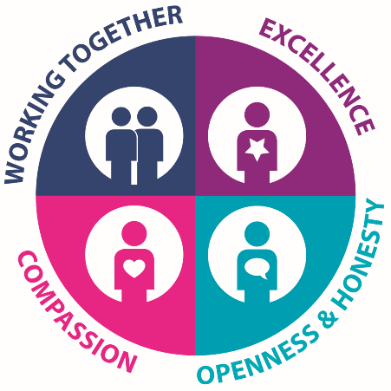 | The report author will complete this report cover sheet fully. The Accountable Director must satisfy themselves that the cover sheet is accurate and fully reflects the report. The expectation is that the Accountable Director has read and agreed the content (cover sheet and report).  Its purpose is to provide the Trust Board/Committee with a clear summary of the report/paper being presented, how it impacts on the people we serve and the key matters for attention and the ask of the Trust Board/Committee

- Reason for Presentation of Paper / Report
- The Trust’s Annual Quality Report is published in response to the Department of Health’s Quality 2020 Strategy.
- Department of Health have requested that all Health & Social Care Trust’s publish their Annual Quality Report to coincide with World Quality Day on Thursday 14th November 2024.
- This report focuses on local developments in respect of improving quality, safety and patient experience. It also includes a core dataset agreed regionally to enable regional context and comparisons for all our stakeholders and service users.
- This report provides an overview for the 2023/24 year with respect to how the Trust performed against a range of core indicators of quality and includes some examples of improvement work led by our staff.
- Detailed summary of paper contents:
- Areas of improvement/achievement:
- (Theme 1: Transforming the Culture) – Our People Framework was launched during 2022. The report outlines key achievements during 2023/24, against the three priorities identified within the Strategy, Wellbeing, Belonging and Growing. A summary of wellbeing programmes for staff have been delivered in the last year and a range of events including culture evenings and Our People Awards, which has promoted a sense of belonging to the organisation. This year has also seen the introduction of the weekly ‘Chat with the Chief’ briefings – ensuring staff are updated on key events, as they happen. The Trust has also continued to support the growth of staff and teams through many training opportunities including vocational training and also the implementation of our Coaching Plan 2023/24. Directorates are fostering a culture of inclusion and belonging and actions to grow our workforce. Directorate Actions Plans are being progressed by Operational Teams.
- (Theme 1: Transforming the Culture) - Personal & Public Involvement has continued to thrive during the 2023/24 year. The Trust formally launched the Working Together Strategy in May 2023. The Personal & Public Involvement tam worked in partnership with colleagues from Quality Improvement and Patient Client Experience alongside service users and carers in the development of this Strategy. Directorate Care Experience Hubs have been established and work to identify, develop and report on a range of improvements each year. Each Hub has a User Involvement Ambassador. Successful Hub improvements include the installation of food vending machines in Emergency Departments etc.
- (Theme 2: Strengthening the Workforce) – During 2023/24 the Senior Leadership Team continued to meet with staff through Leadership Walks visiting teams across all services. The Senior Leadership Team Visibility Plan was developed and continues to be implemented moving forward. This has received positive feedback and has emphasised the communication of our vision, ambition, values and culture across services. This has been widely welcomed by all teams and feedback has been highly positive. During 2023/24 we celebrated Internation Women’s Day, International Day of Persons with Disabilities, celebrated Culture Nights and our REACH Staff Network continues to grow, and we have seen a 124% increase since 2022. Our HSC LGBTQ+ Staff Forum walked in the Pride Parade in July 2023.
- (Theme 2: Strengthening the Workforce) – During 2023/24 the Trust experienced a 32% increase in uptake of the Corporate Welcome, with compliance levels reaching 71%. In-person Corporate Welcome will return in 2024/25 year with sessions already underway. In addition, Corporate Mandatory Training compliance levels have also seen a significant improvement in the last year, with further efforts to address this being planned throughout the autumn.
- (Theme 3: Measuring the Improvement) & (Theme 4: Raising the Standards) - provides an overview of key indicators of quality which are measured by the Trust. The following improvements were achieved during 2023/24:
- Patient falls reduced by 16% from 2022/23 period, from 1512 in 2022/23, to 1265 at 31st march 2024.
- Safer Surgery / WHO Compliance increased to 97.9%.
- Venous Thromboembolism (VTE) compliance increased to 96%.
- Reduction in incidence of MRSA (decrease of 6 cases), cDiff (decrease of 3 cases).
- Hospital Readmissions within 7 days continues to remain below the regional target of 5% - achieving 4.2%.
- Emergency Department Triage to Examination Time has seen an improvement with patients being seen faster reducing from 65.5 median minutes during 2022/23 to 56 median minutes during 2023/24.
- Emergency Department has also seen an improvement with a reduction of the number of patients who leave without treatment being complete – 5.9% of patients during 2023/24, down from 7.9% in 2022/23.
- 31 day Cancer Standard; improved position of 91%, increasing from 86% during 2022/23, however remains below target.

- Areas of concern/risk/challenge:
- (Theme 3: Measuring the Improvement) & (Theme 4; Raising the Standards) - provides an overview of key indicators of quality which are measured by the Trust. Detailed below are areas of concern based on 2023/24 year-end positions, noted in the report:
  - 62 day Cancer Standard: decreased to 40.9%, this represents a further reduction on 2022/23 position of 42%.
  - The Trust achieved 22.4% of all Breast Cancer patients being seen within 14 days. This represents a reduction on the 2022/23 position of 56%. This still remains significantly lower than pre-pandemic levels of 2019/20 when 99% achieved. The Trust continues to experience workforce challenges in this area, efforts are ongoing to address this by maximising internal capacity and progressing external recruitment. The Trust also acknowledges this performance is not providing the best experience for service users at this time;
  - Emergency Department 4 Hour Standard: patients seen or admitted within 4 hours has reduced from 52.4% in 2022/23 to 50.6% in 2023/24.
  - Emergency Department 12 Hour Standard: patients waiting over 12 hours to be seen or admitted increased from 14.7% during 2022/23 to 16.7% in 2023/24.
  - Emergency Department Hospital Readmissions within 28 days: during 2023/24, 7% of patients were readmitted within 28 days of discharge. This is a marginal increase on the position from 2022/23 where 6.80% of patients were readmitted within 28 days. The Trust position remains above the regional 5% target.
Efforts will be focused moving forward to address these concerns/challenges as part of the Service Delivery Plan reporting and monitoring process.
- Impact on Statutory Duties: Provide details on the impact of the following and how.
Financial Impact |  |  | Safety and Quality Impact
No, there are no Financial Impacts |  |  | Yes, there are Quality, Safety or Experience Impacts
- Risk Assessment (Risk level and state if a risk assessment be completed)
- Other Business Intelligence/data (If appropriate)
- Impact: Provide details on the impact of the following and how. If this is N/A you should explain why this is an appropriate response.
Corporate Risk Register | Any risks identified are managed accordingly with Directorate/Corporate Risk Registers as appropriate.
Board Assurance Framework | Any strategic risks where identified are managed and assurance provided as outlined in the Board Assurance Framework.
Equality and Human Rights |  | Equality and Human Rights are duly considered in service provision across all Directorate areas.

