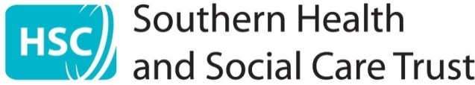

TRUST BOARD COVER SHEET

Meeting and Date of meeting | Trust Board  Thursday 21st November 2024
Title of paper | Trust Board Chair Update
Accountable Director | Name |  | Eileen Mullan
Accountable Director | Position |  | Trust Board Chair
Report Author | Name |  | Eileen Mullan
Report Author | Email |  | Trust Board Chair
This paper sits within the Trust Board role of: |  |  | Accountability
This paper is presented for: |  |  | Discussion
Links to Trust Corporate Objectives | ☒ | Unscheduled Care Transformation and Reform
Links to Trust Corporate Objectives | ☒ | Improved Access to Services
Links to Trust Corporate Objectives | ☒ | Focus on developing services provided in the Community
Links to Trust Corporate Objectives | ☒ | Ensure Safe Services while delivering financial recovery
Links to Trust Corporate Objectives | ☒ | Strengthen Financial and Governance Systems
Links to Trust Corporate Objectives | ☒ | Digital Readiness
Links to Trust Corporate Objectives | ☒ | Sustainability of Our Estate
Links to Trust Corporate Objectives | ☒ | Embedding Our Co-production Approach
Links to Trust Corporate Objectives | ☒ | Delivery of Year 3 of Our People Framework



1: Ministerial Statements
22nd October 2024 | Ministerial Statement Maternity and Neonatal Services
23rd October 2024 | Children with Disabilities Short Breaks
24th October 2024 | Addressing Health Inequalities – Announcement of Live Better Areas
30th October | Radioisotopes Shortage

2: Northern Ireland Assembly

- Committee for Health Thursday 3 October 2024
- Question Time: Minister for Health, Tuesday 15 October 2024
- Committee for Health Thursday 17 October 2024
- Ministers Statement - Maternity and Neonatal Services 22nd October 2024Committee for Health Thursday 24 October 2024

3: Chair and Non-Executive Directors Business and visits
- These can be found within the information section at the end of the meeting pack.

4: For information
- Minister of Finance Oral Statement - Public Expenditure 2024-25 October Monitoring - 11 November 2024 (finance-ni.gov.uk)
- NI Audit Office Report - The National Fraud Initiative in NI 2024.pdf

