The Brackens
Trust Headquarters, Craigavon Area Hospital, 86 Lurgan Road, Portadown, BT63 5QQ
*Continue past Trust Headquarters and The Brackens will be straight ahead at the end of the road

Venue Information for encompass Training
Info | Details
Parking | Parking available outside the building.
Access to Building | The building is accessible between 9am - 5pm, Monday – Friday. Access control and key will be required outside of these hours.
Access to Training Rooms | As above.  All trainers should refer to detailed access information provided in separate documentation.  Ensure rooms are left tidy, valuables are locked away and all windows / blinds are closed and doors locked (if required) at the end of the training sessions.
IT PC Log on Issues | SHSCT – Encompass Training Teams Channel
Estate Service Help Desk | SHSCT – Encompass Training Teams Channel
Emergency Contact | Gareth Murphy - 07741235786
Planned Fire Drills | A Fire Alarm Test is carried out every Monday.  Unannounced Fire Evacuation carried out in September each year.
Fire Assembly Point | Fire Assembly Point L located at the front of The Brackens and adjacent to The Oaks.  Trainer to familiarise themselves with fire evacuation procedures at the facility.
Toilets | Toilets located onsite.
Catering Facilities | Nearest canteen located in Trust Headquarters, available for breakfast and lunch.
Smoking | This is a SMOKE FREE site. Staff must go off Trust premises to smoke. This includes the use of e-cigarettes.

Emergency Fire Exit Floor Plans - The Brackens
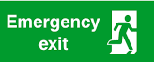
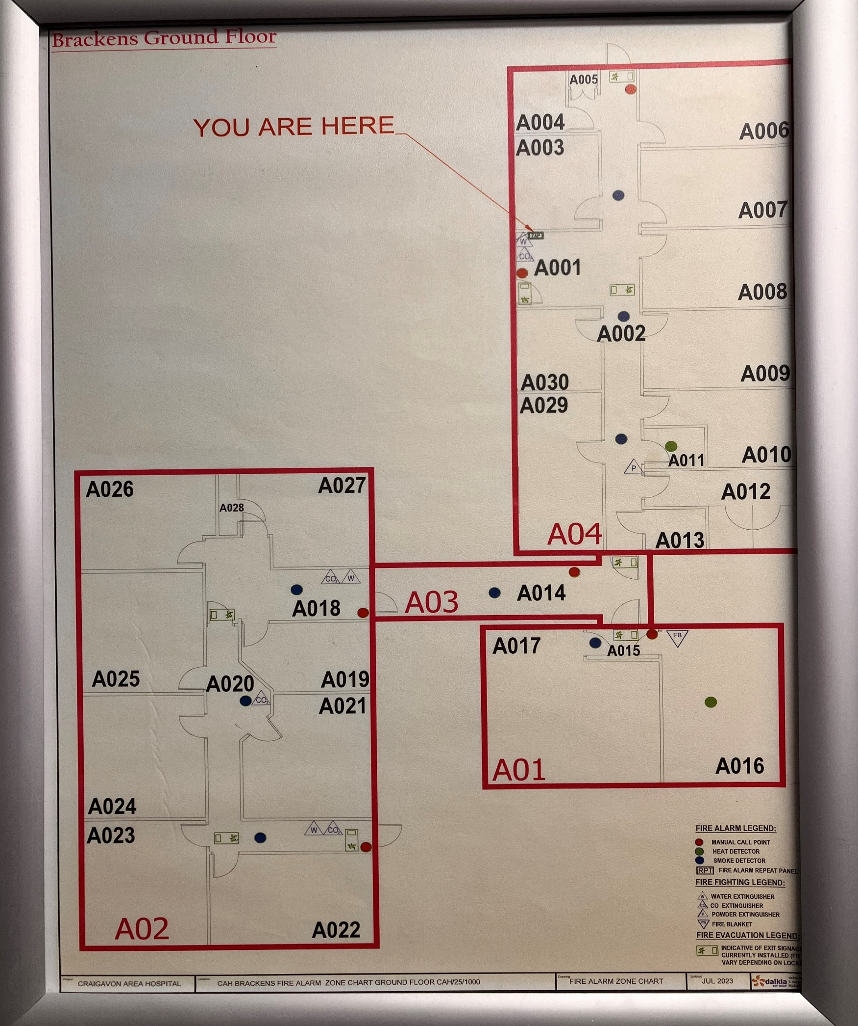
Meeting Room

